

Name: Divyaben Patel

Assignment topic: Defect Tracking System

Student ID: 8790652

Date: 26th January 2022

Assignment: 1

_____________________________________________________

Defect Tracking System

1. Screenshots of all individual defects by severity and with feature request/enhancement with MantisBT…………………………………………………………………. 2
2. Screenshots of “summary” and “summary­ – by severity reports of the defects that were logged in MantisBT …………………………………………………………………. 41
3. Analysis of all the defects and recommendation…. 44
4. Image Reference……………………………………………………… 45
5. Screenshots of all individual defects by severity and with feature request/enhancement with MantisBT.
   1. Phone number field in the registration form has incorrect spelling of phone.

**Severity**: text.

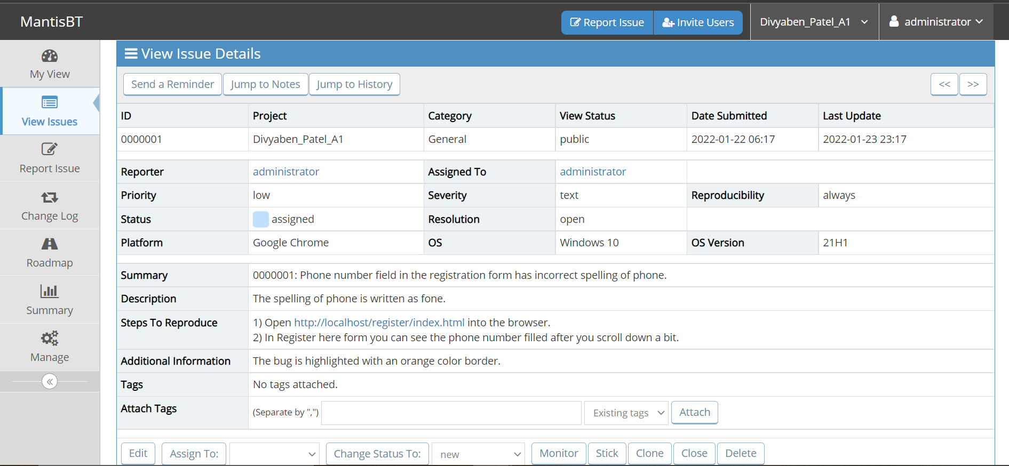

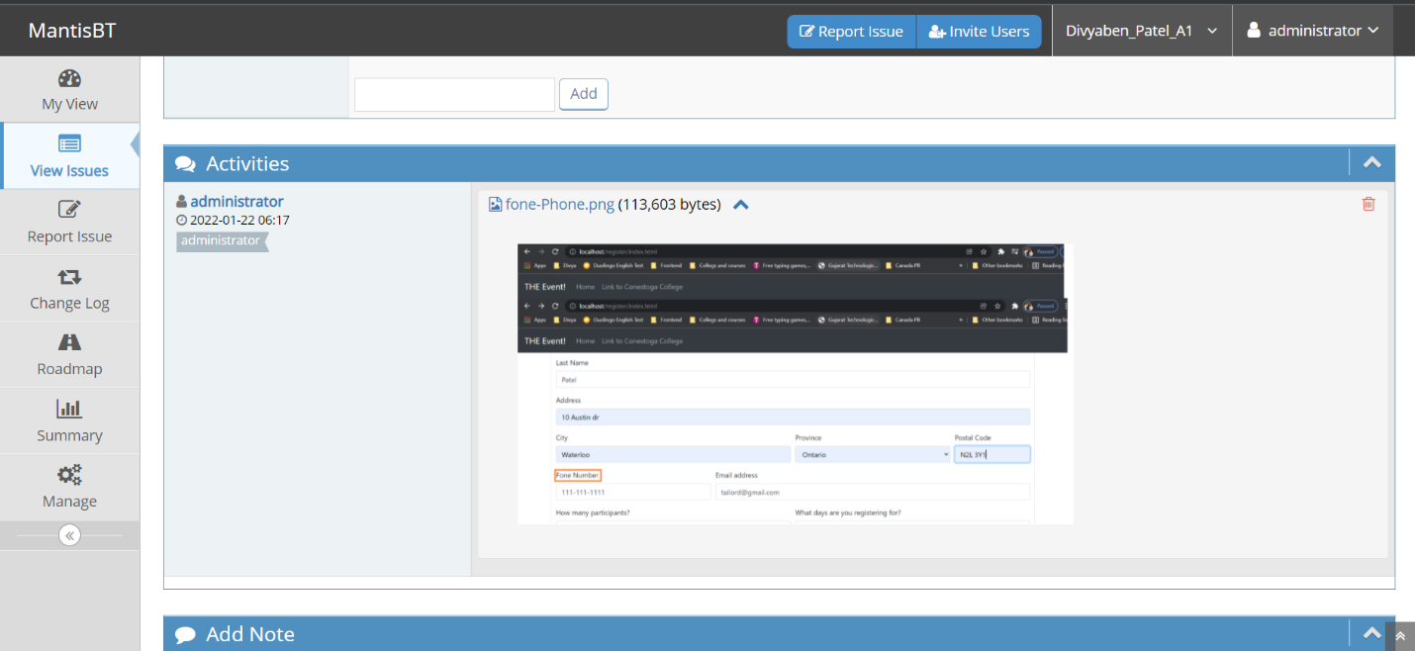

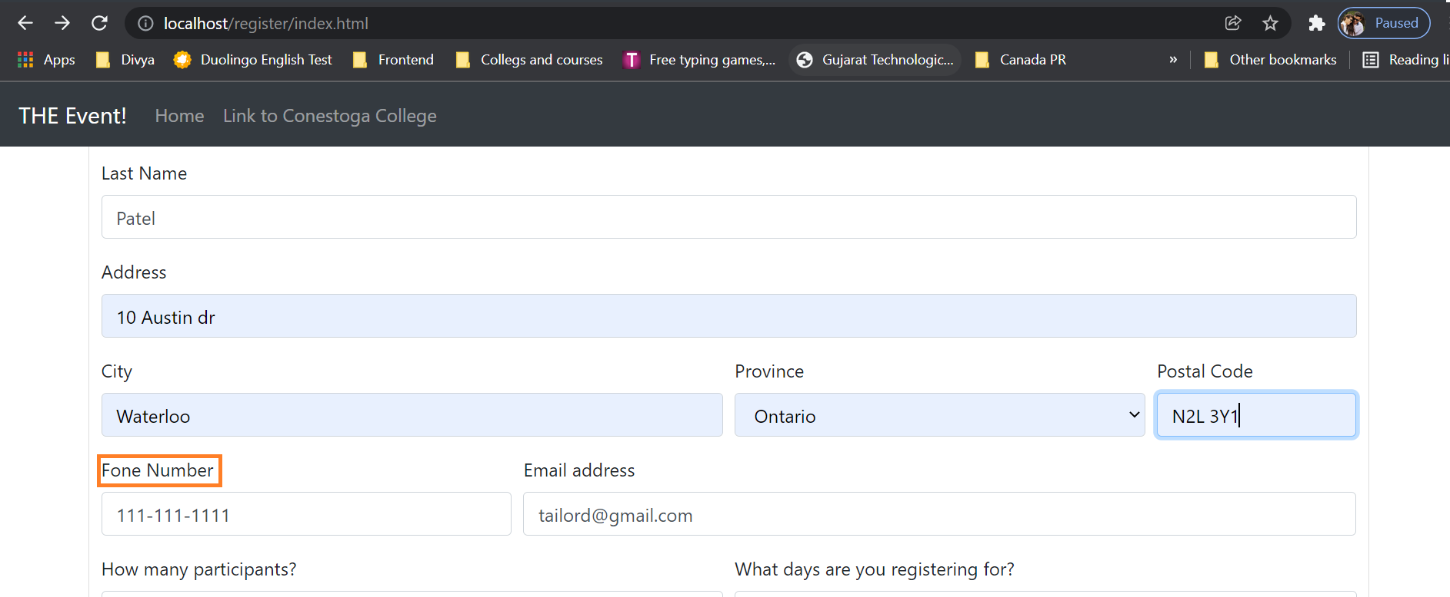

* 1. Provinces are not in an increasing alphabetical order; it also has few errors with provinces name.

**Severity**: major.

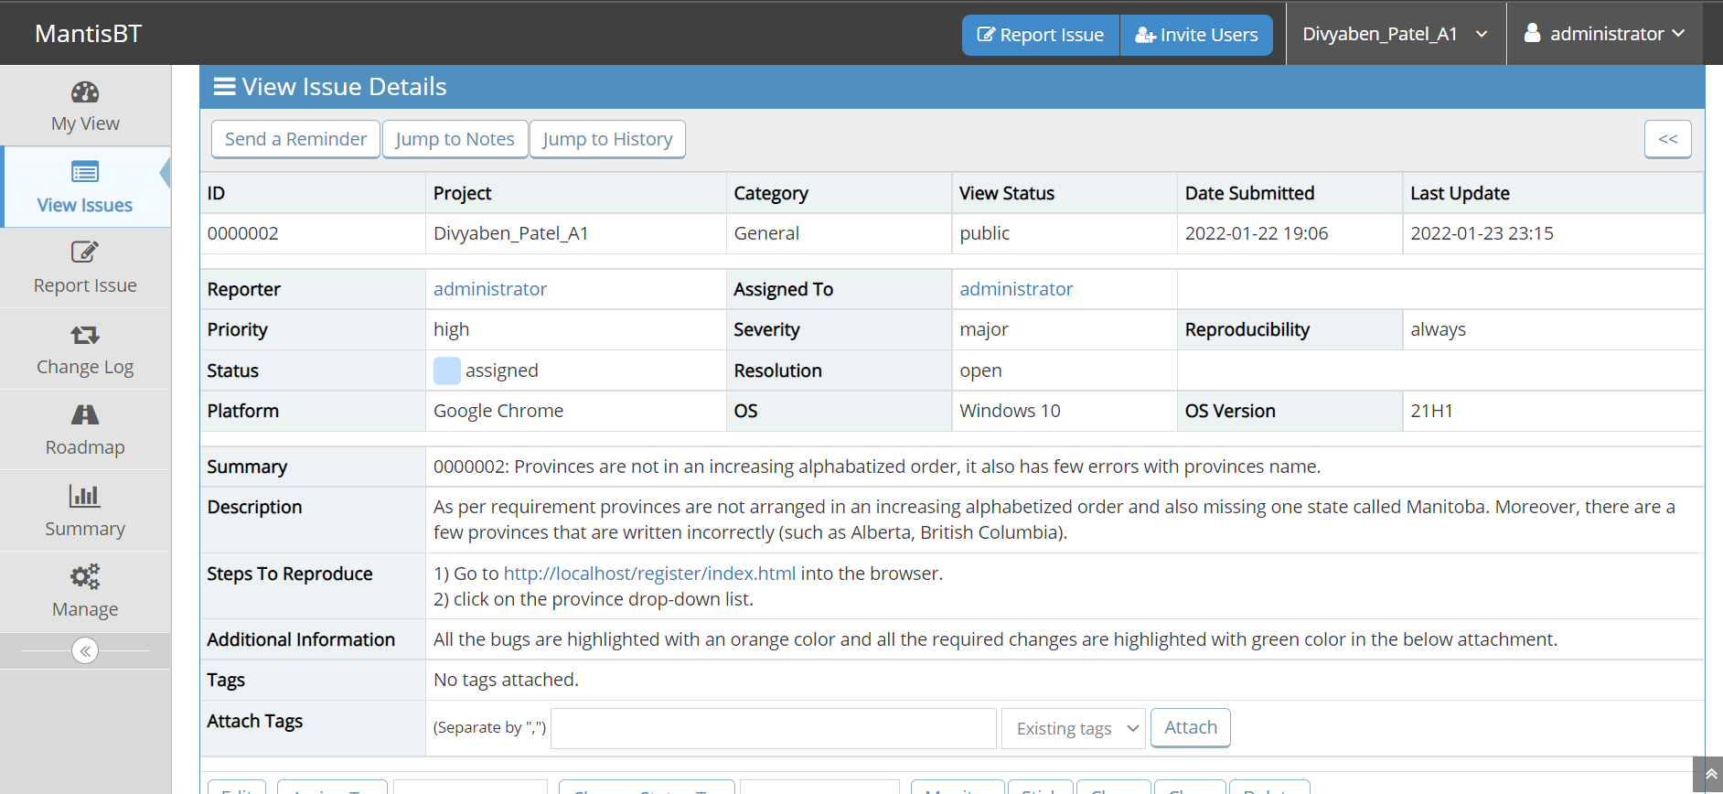

1.2.1 The below image has defects in many provinces name.

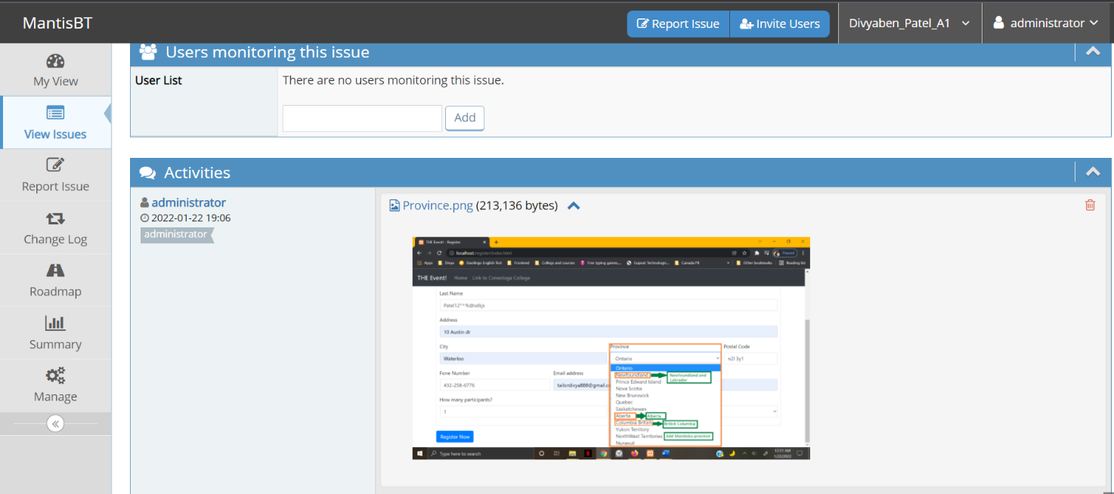

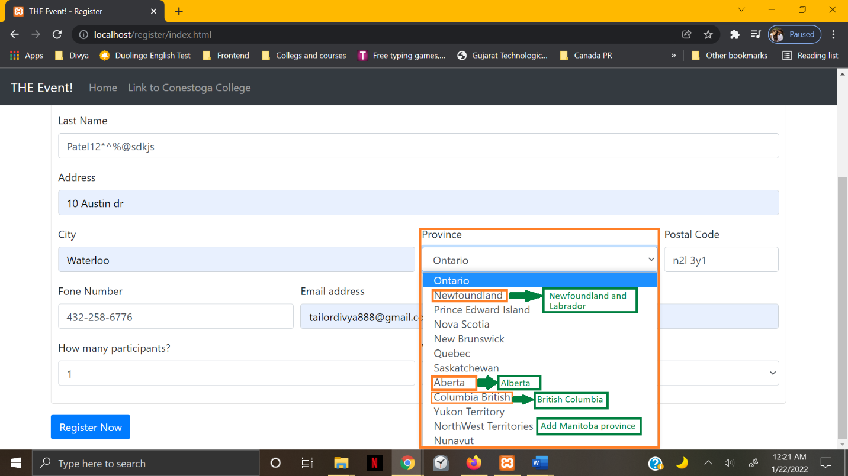

1.2.2 Below image is referred to shows that, how the provinces order

should be in an increasing alphabetical order.

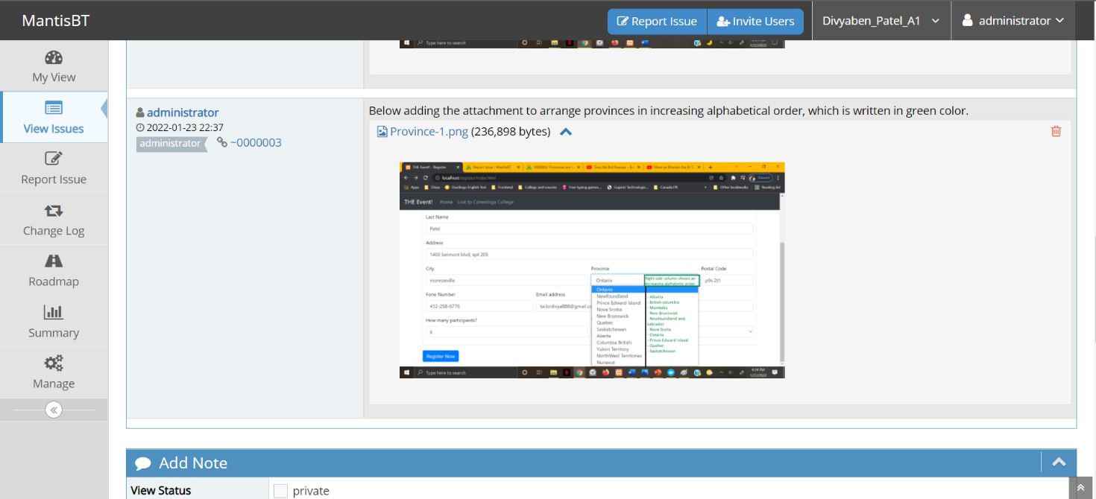

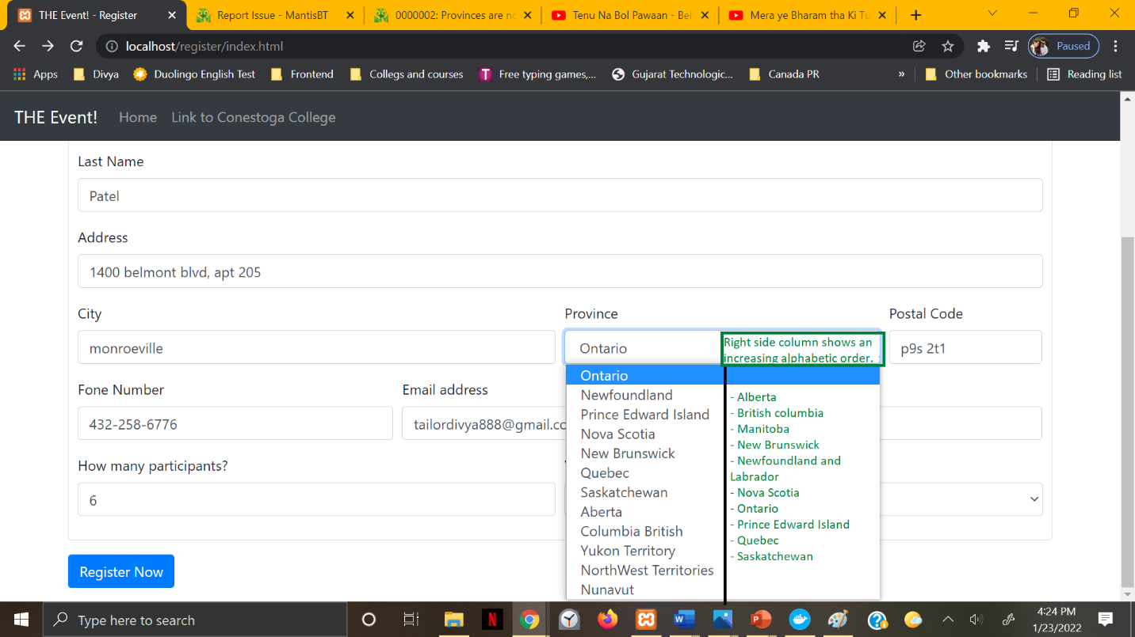

* 1. City field in the registration form accepting all the names and numbers which are not even part of the selected province.

**Severity**: major.

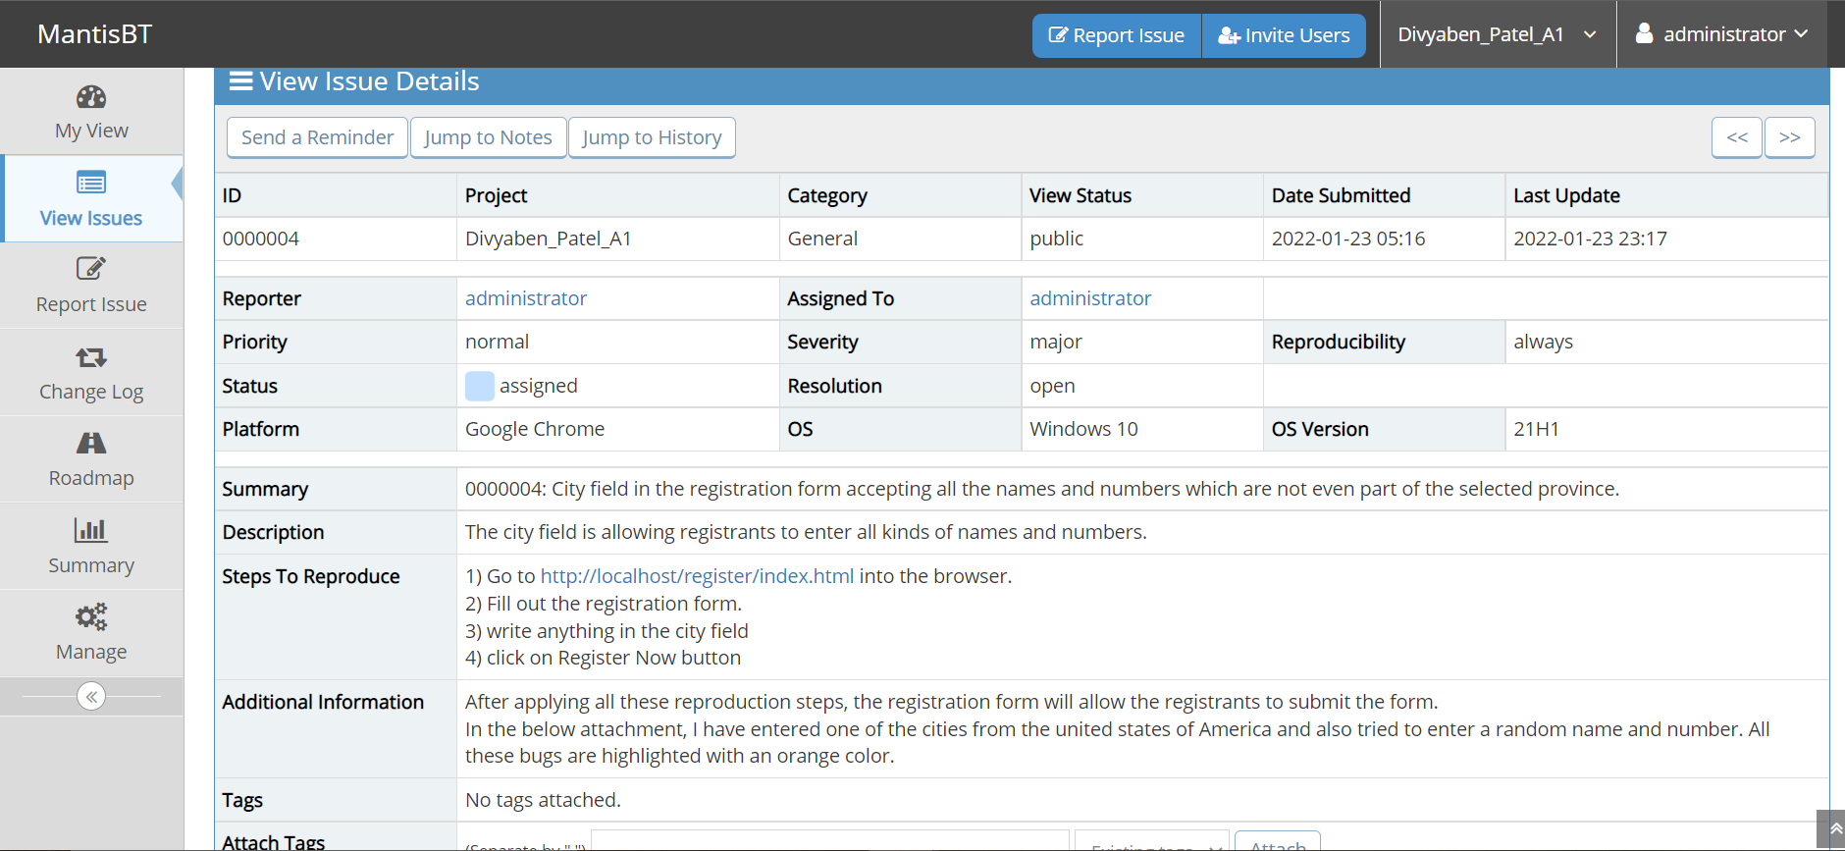

1.3.1 This image shows one of the cities from the United States of America.

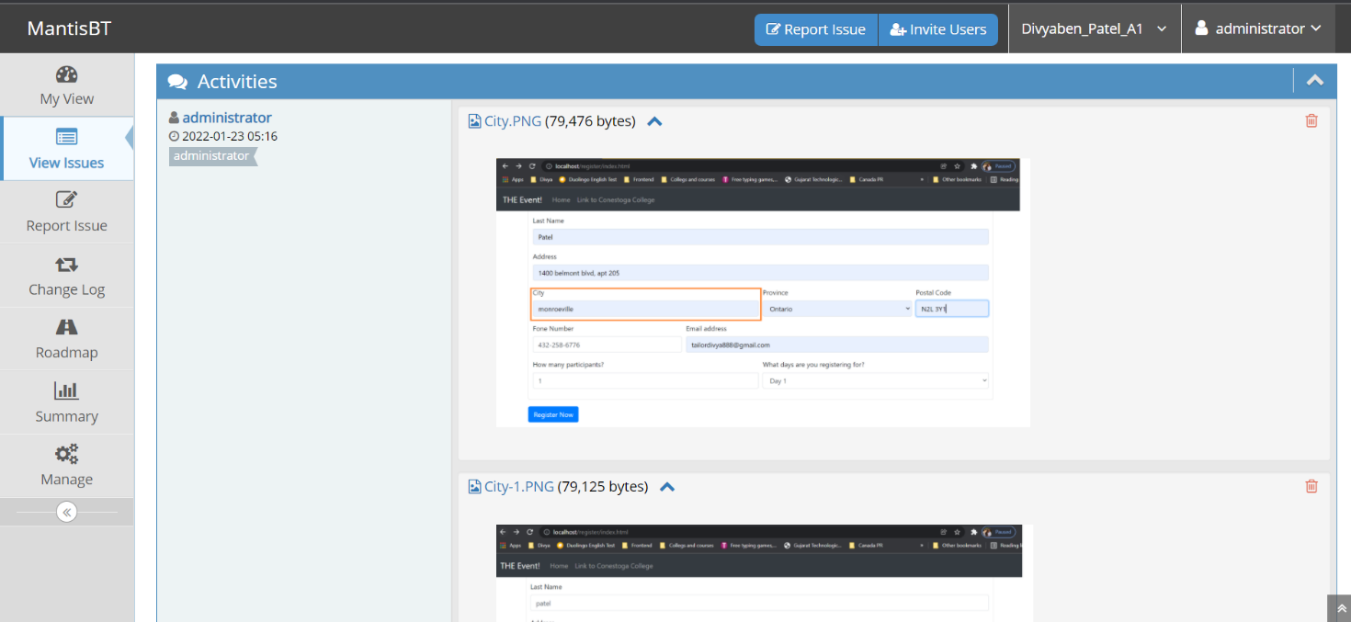

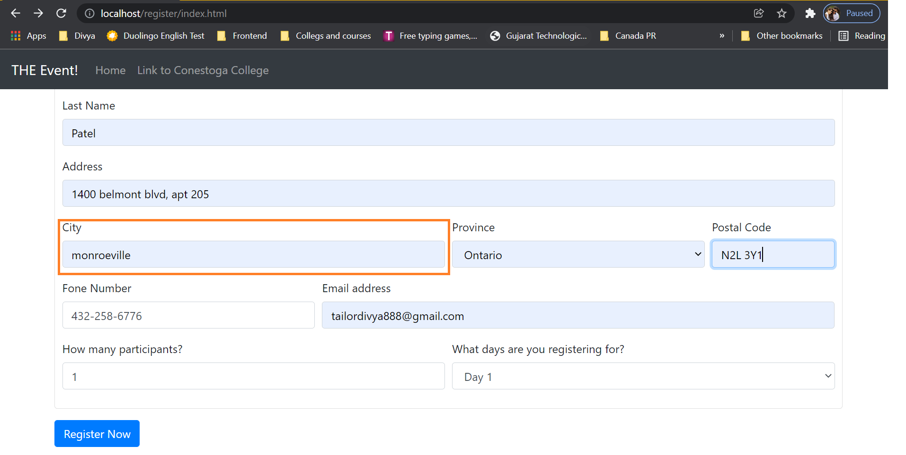

* + 1. This image shows city field accepting random name names.

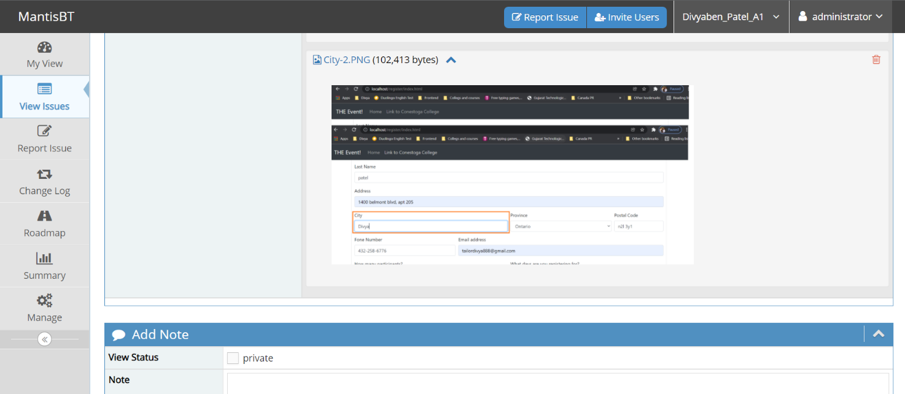

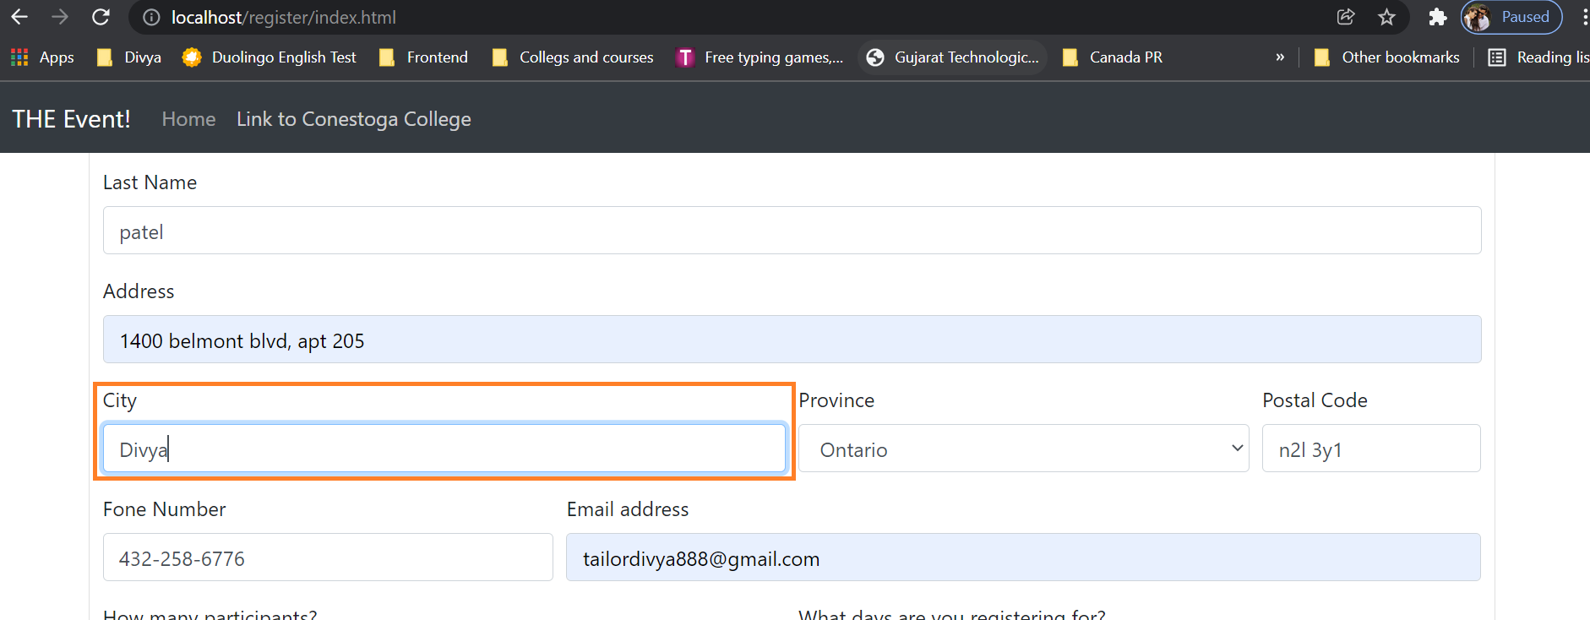

* + 1. The below image shows the city field allowing all the numbers and special characters.

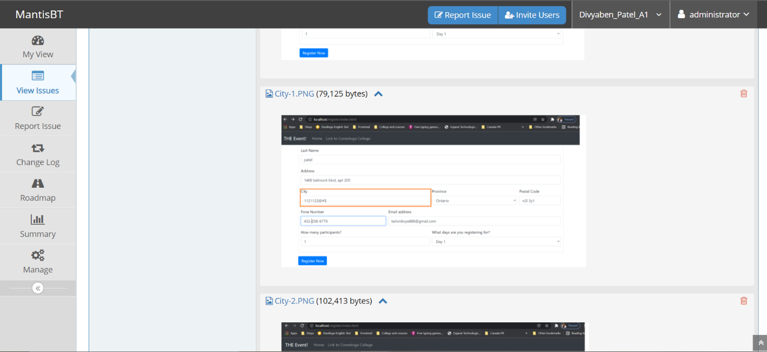

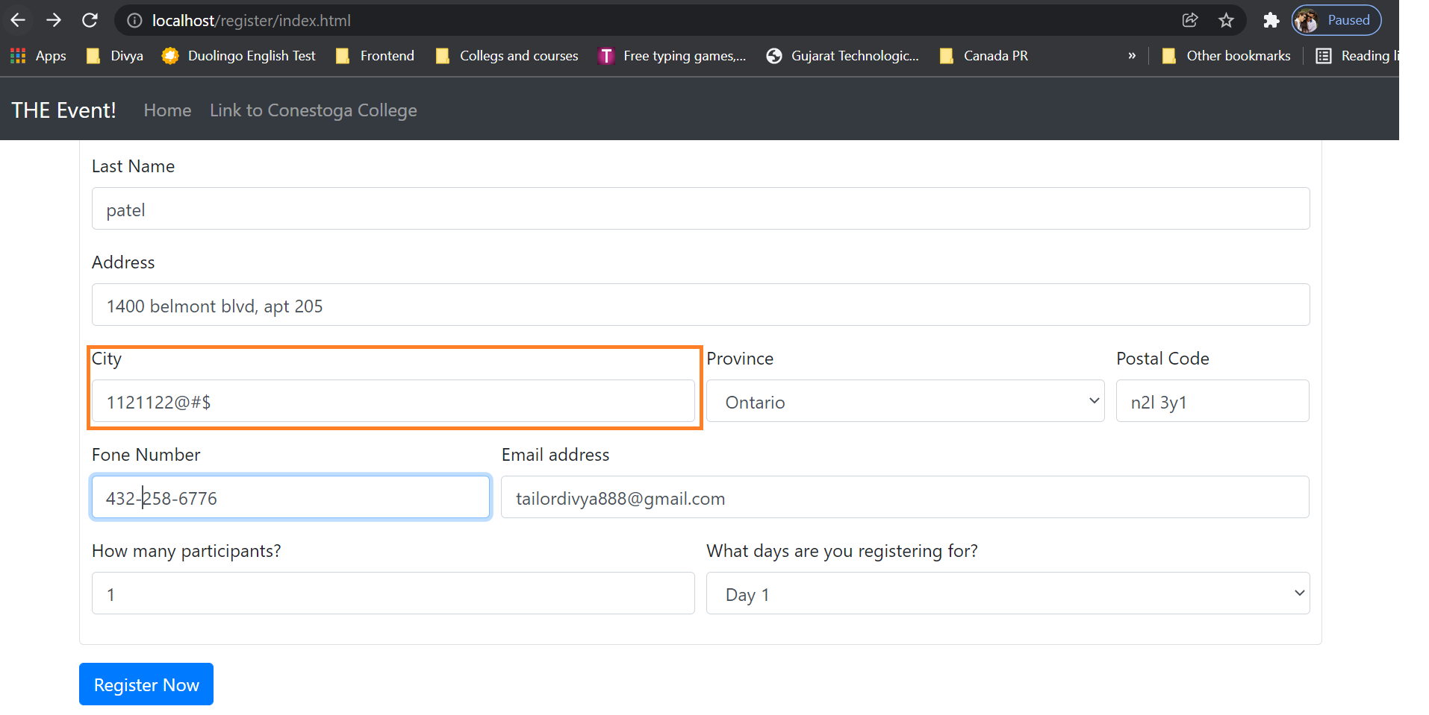

* 1. Phone number field shows error message for one valid pattern.

**Severity**: minor.

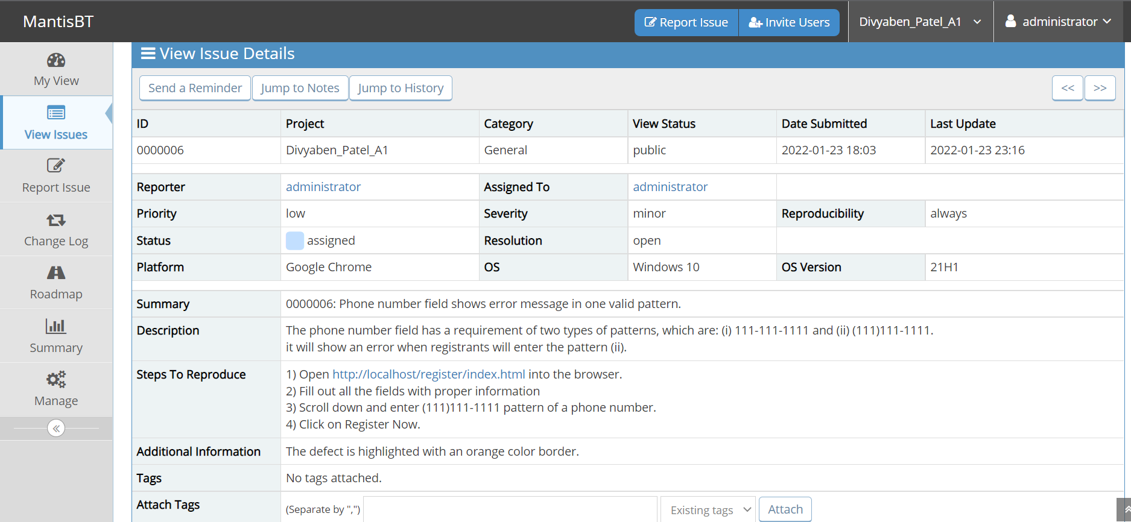

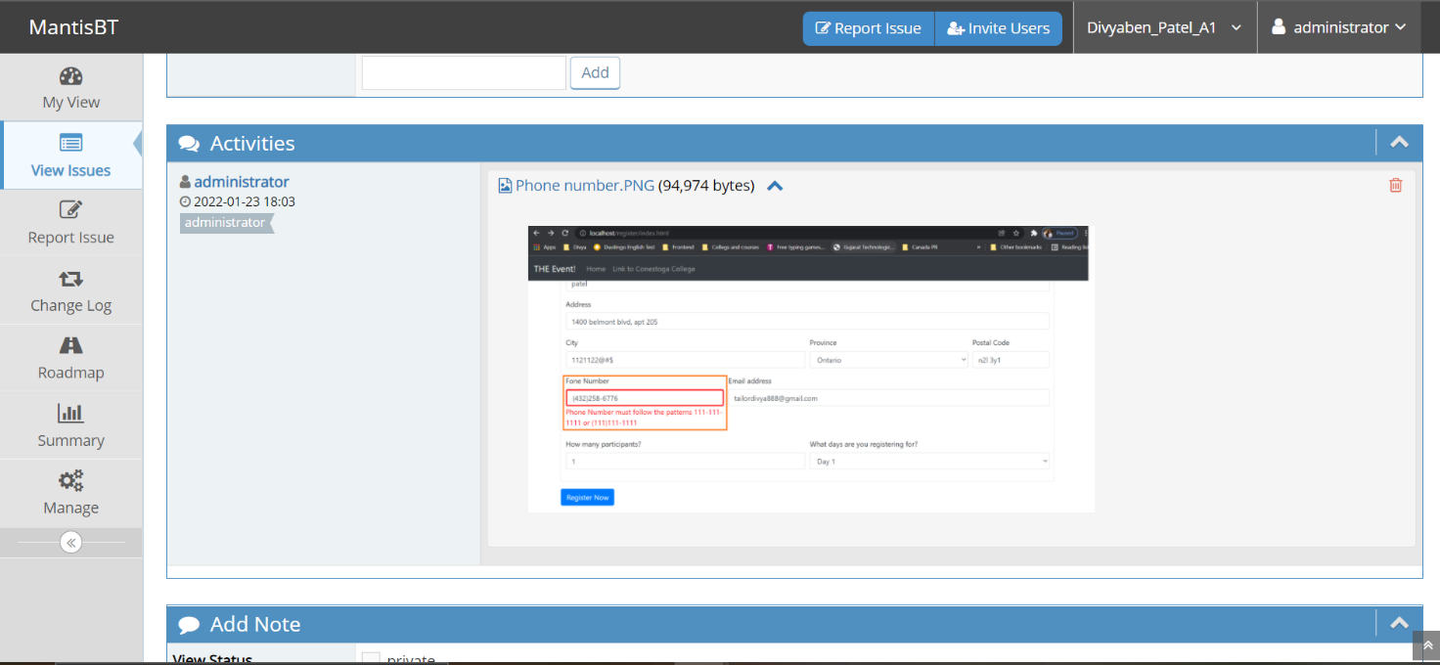

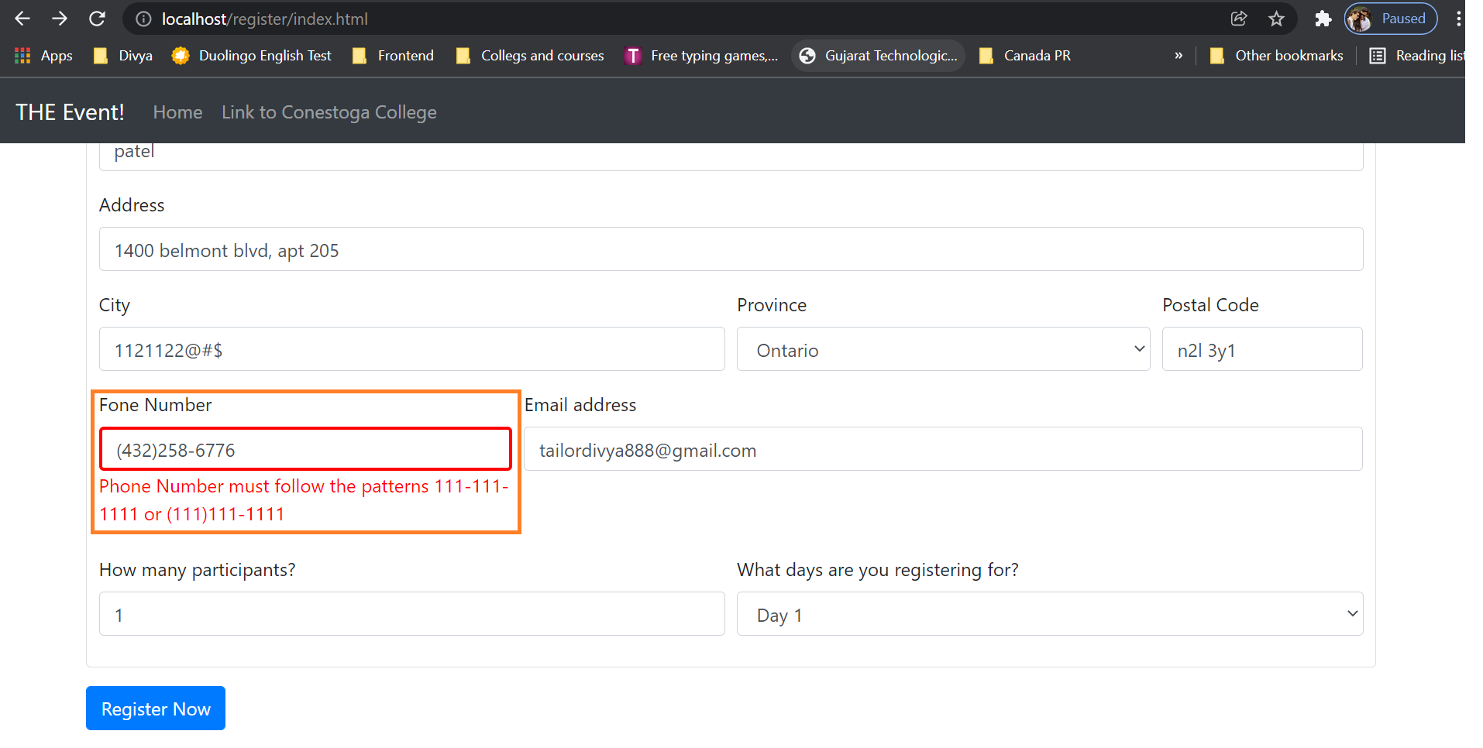

* 1. Amount for day 1 per registrants is wrongly displayed. Amount for more than one participant for day 1 has the same issue.

**Severity**: major.

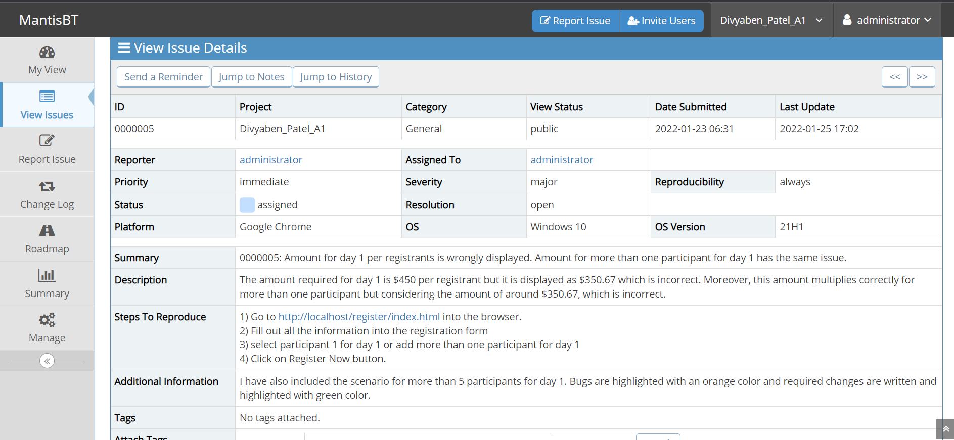

1.5.1 The below tow images are to show the price for participant 1 for day 1 event.

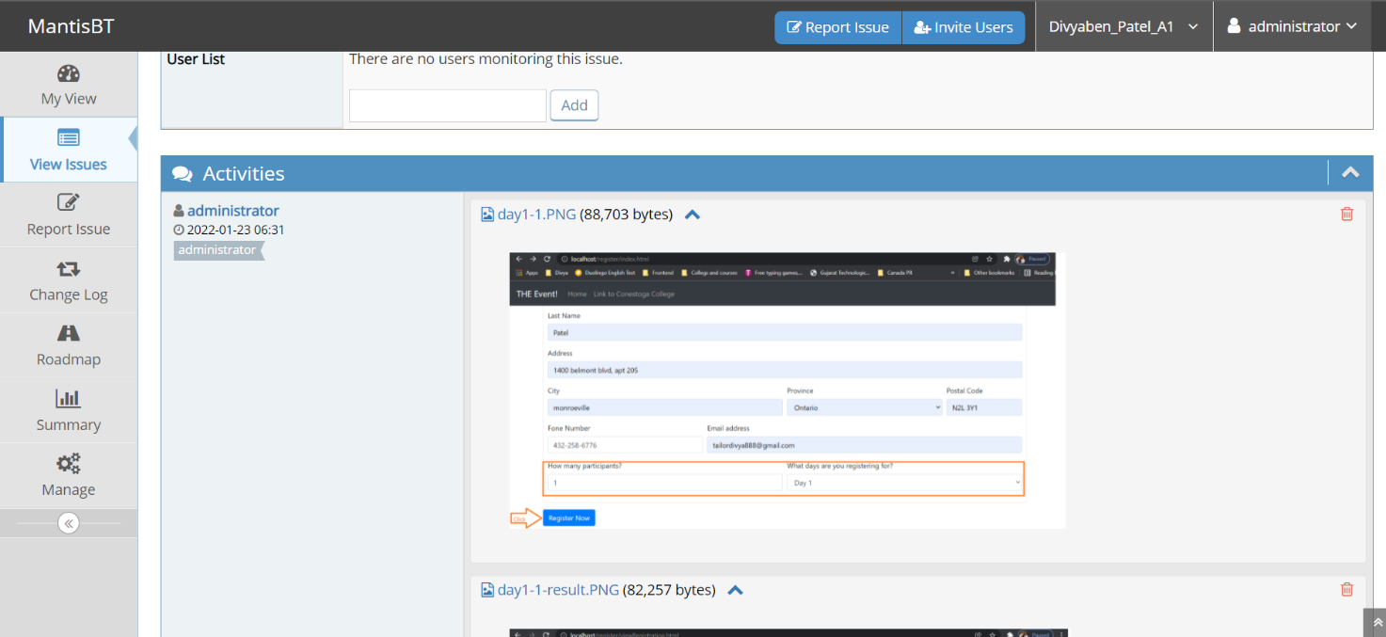

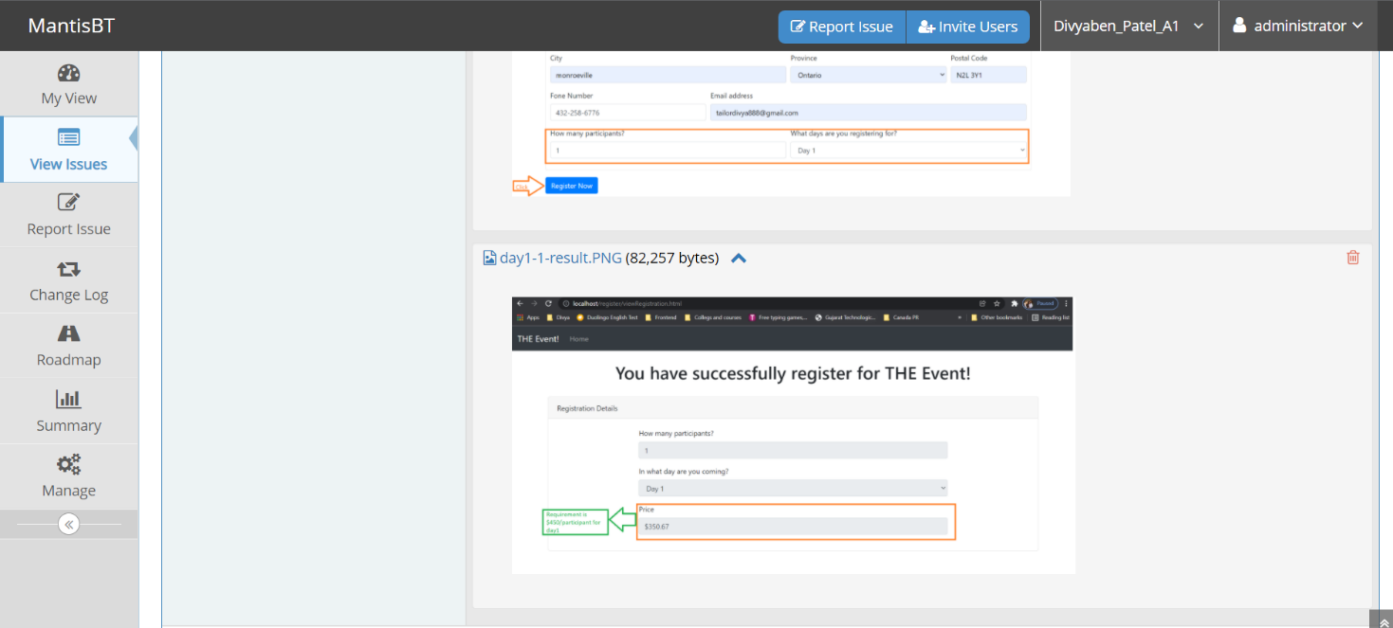

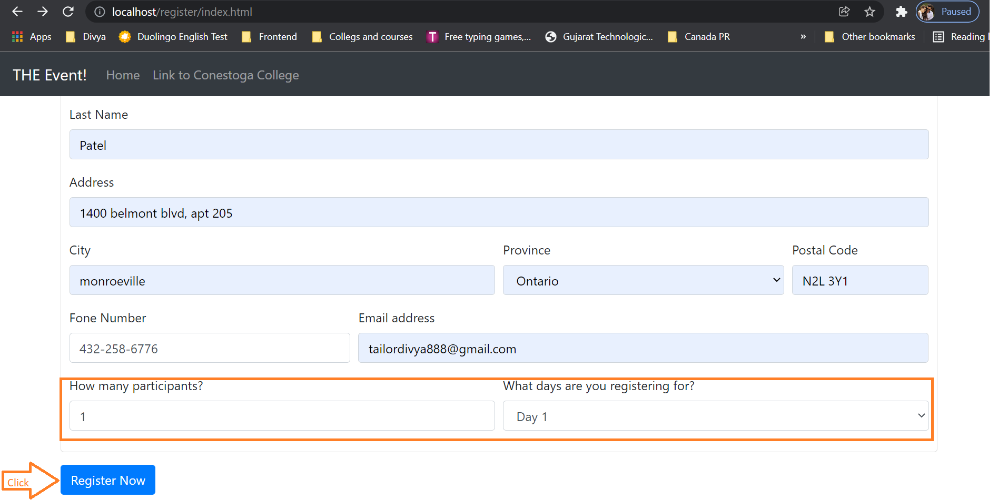

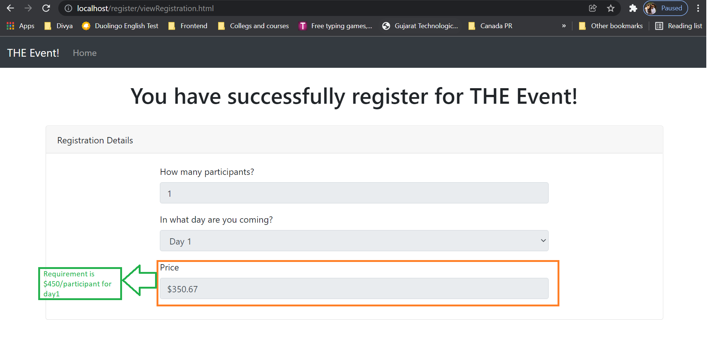1.5.2 The below four screenshots are for more than 1 participants for day 1.

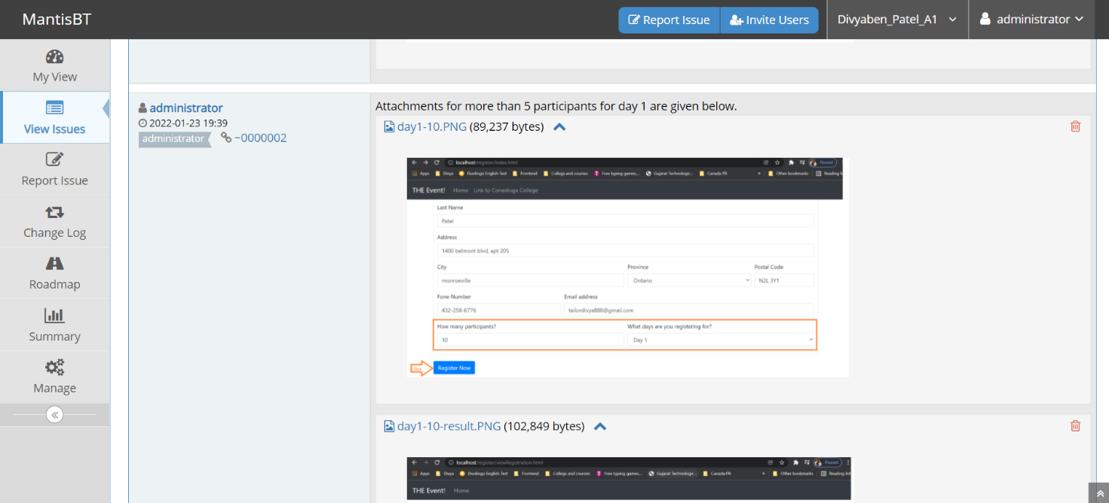

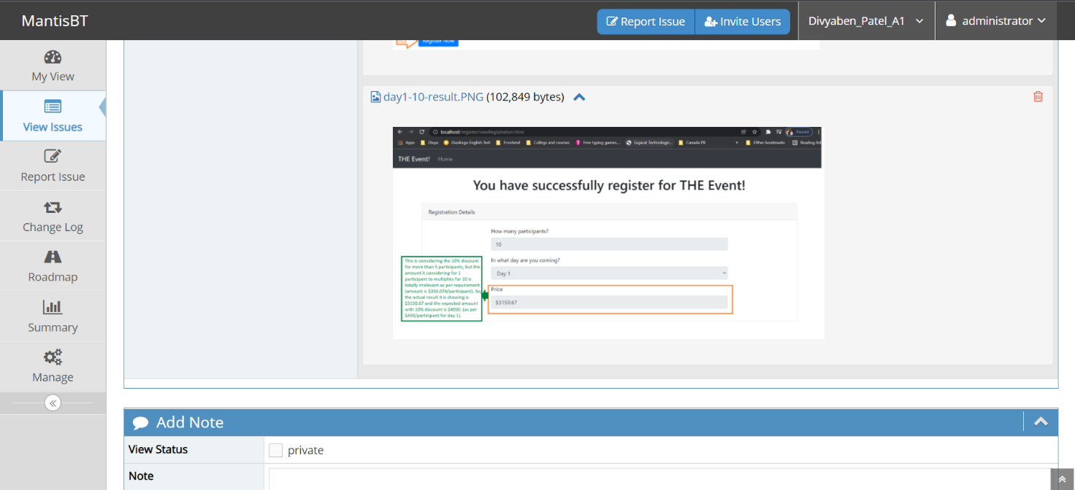

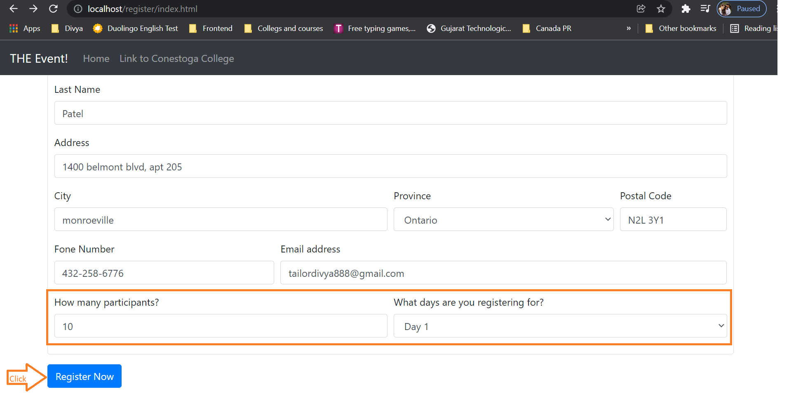

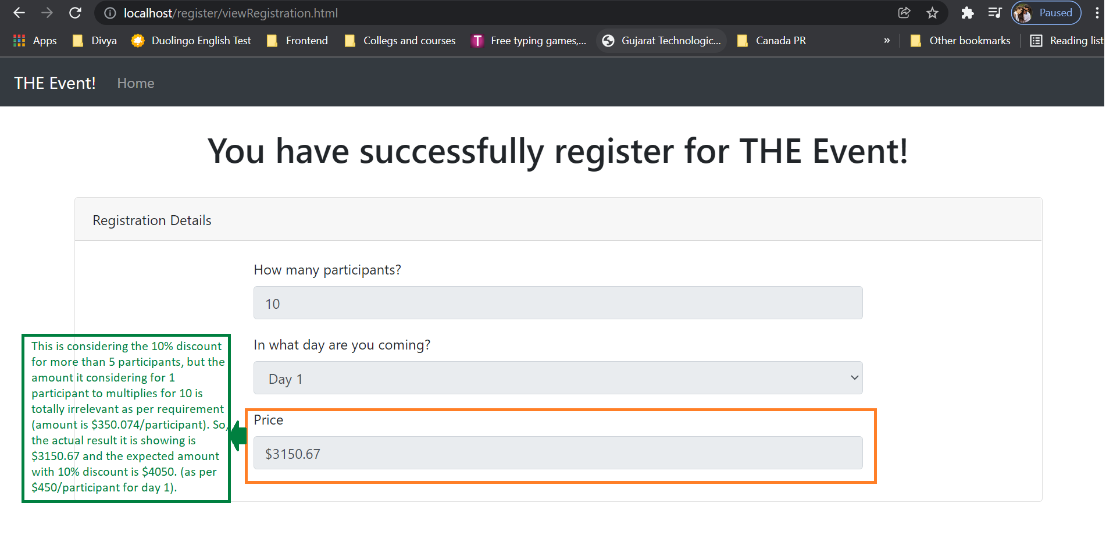

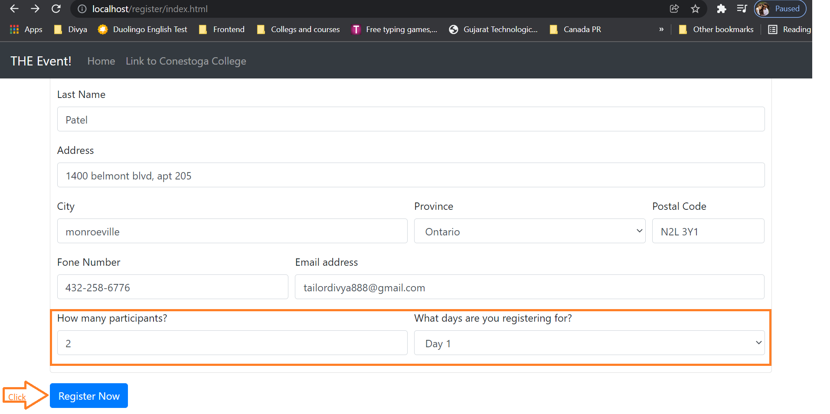

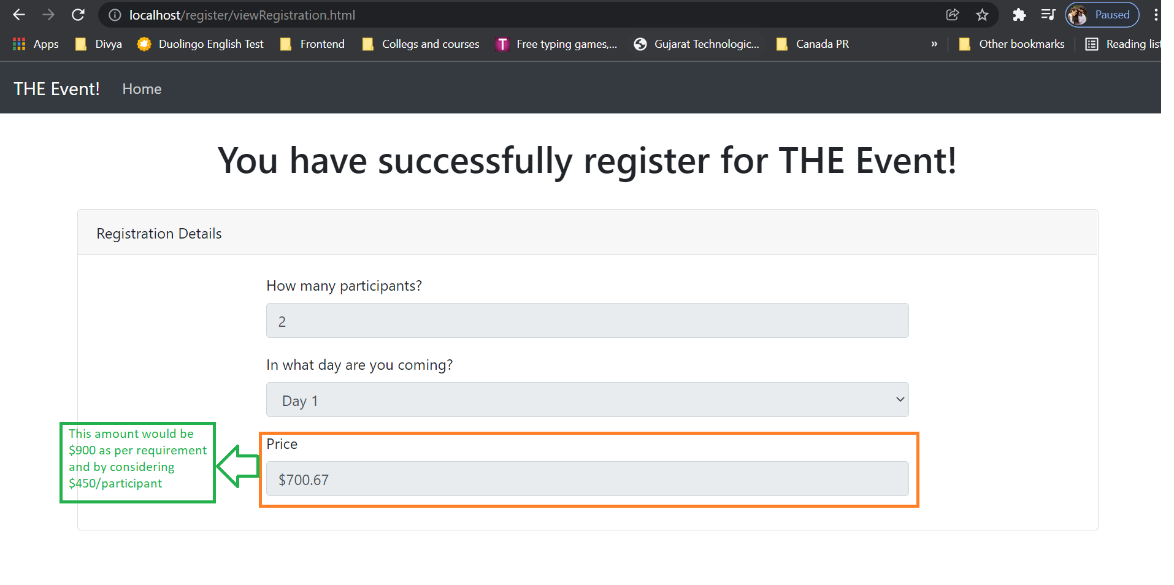

* 1. View registration page is showing wrong day for selected day "Day 2". Also, the amount displayed for day 2 is incorrect.

**Severity**: major.

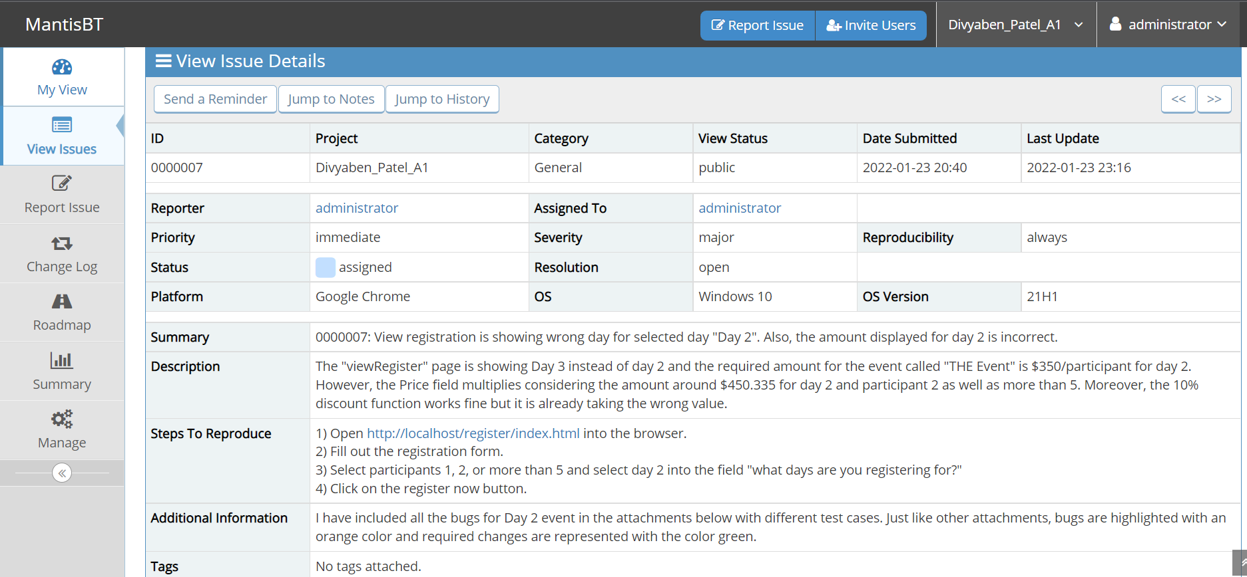

1.6.1 The below two images are for participant 1 for day 2 event.

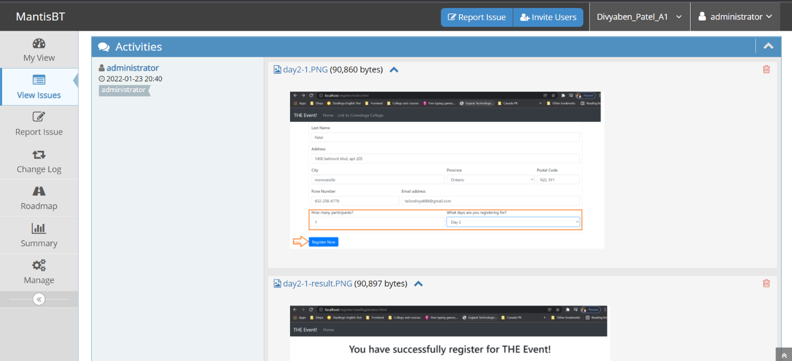

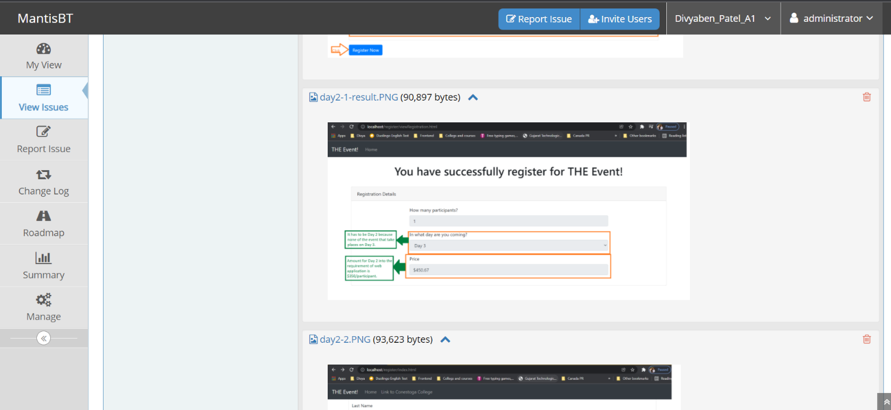

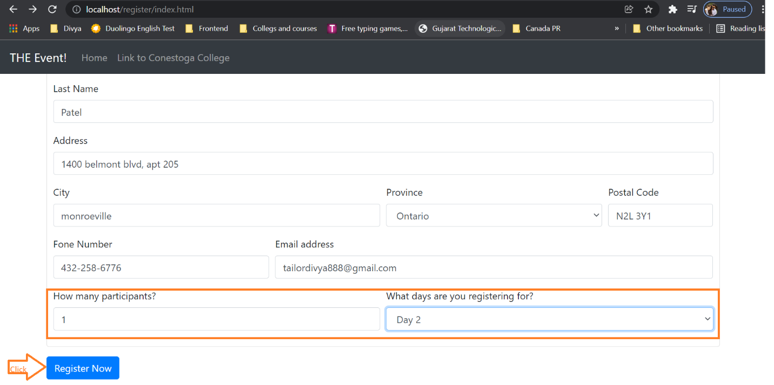

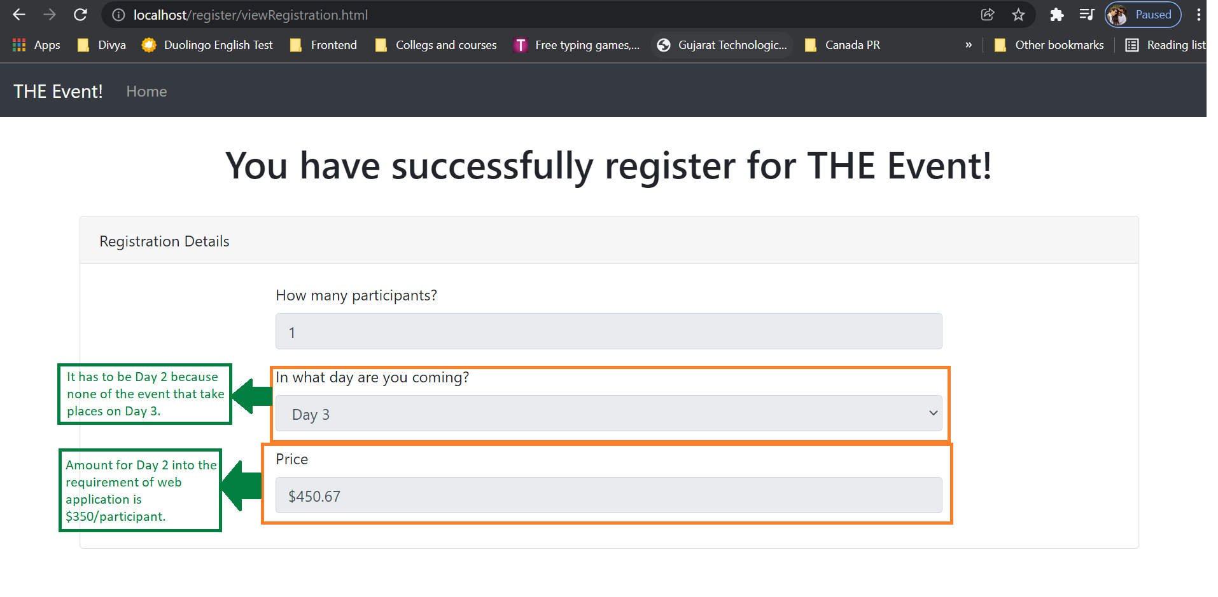

1.6.2 The below four images for more than 1 participants for event on day 2.

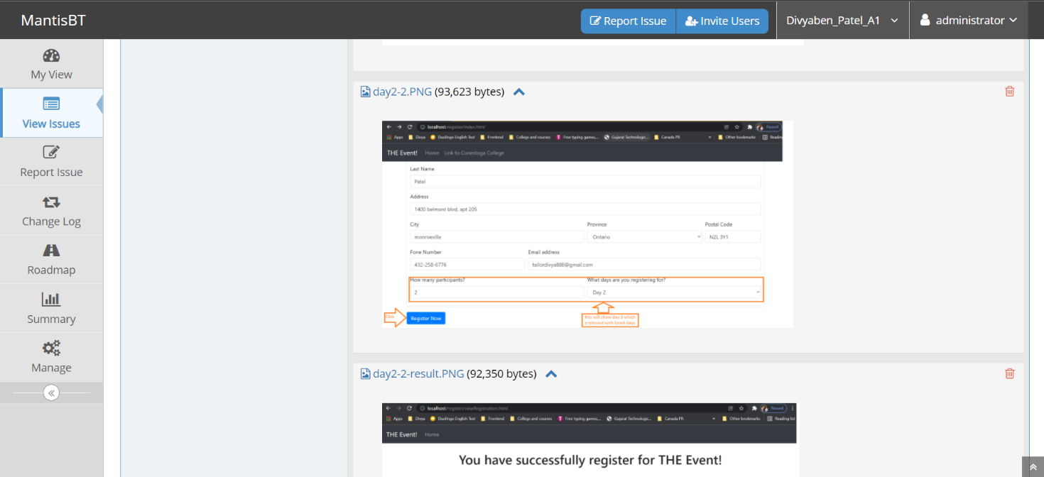

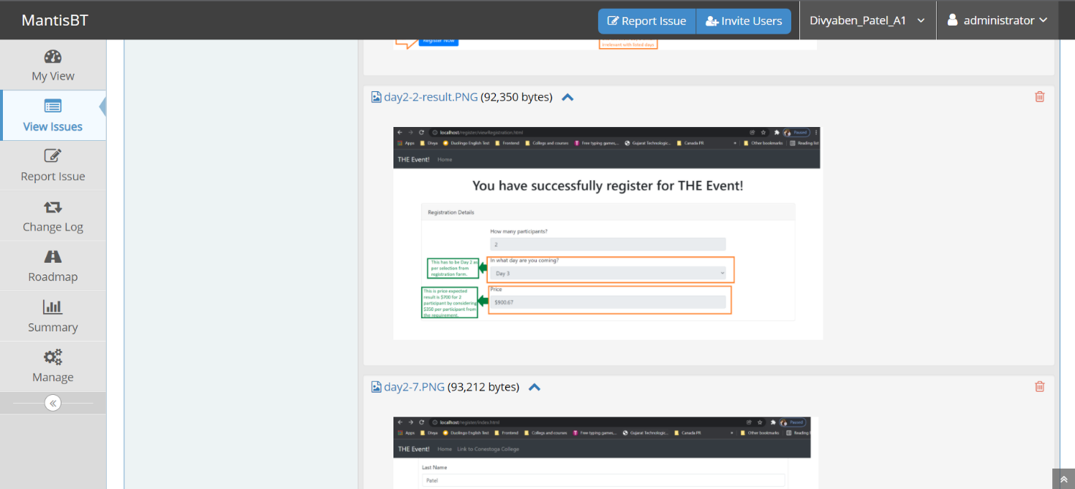

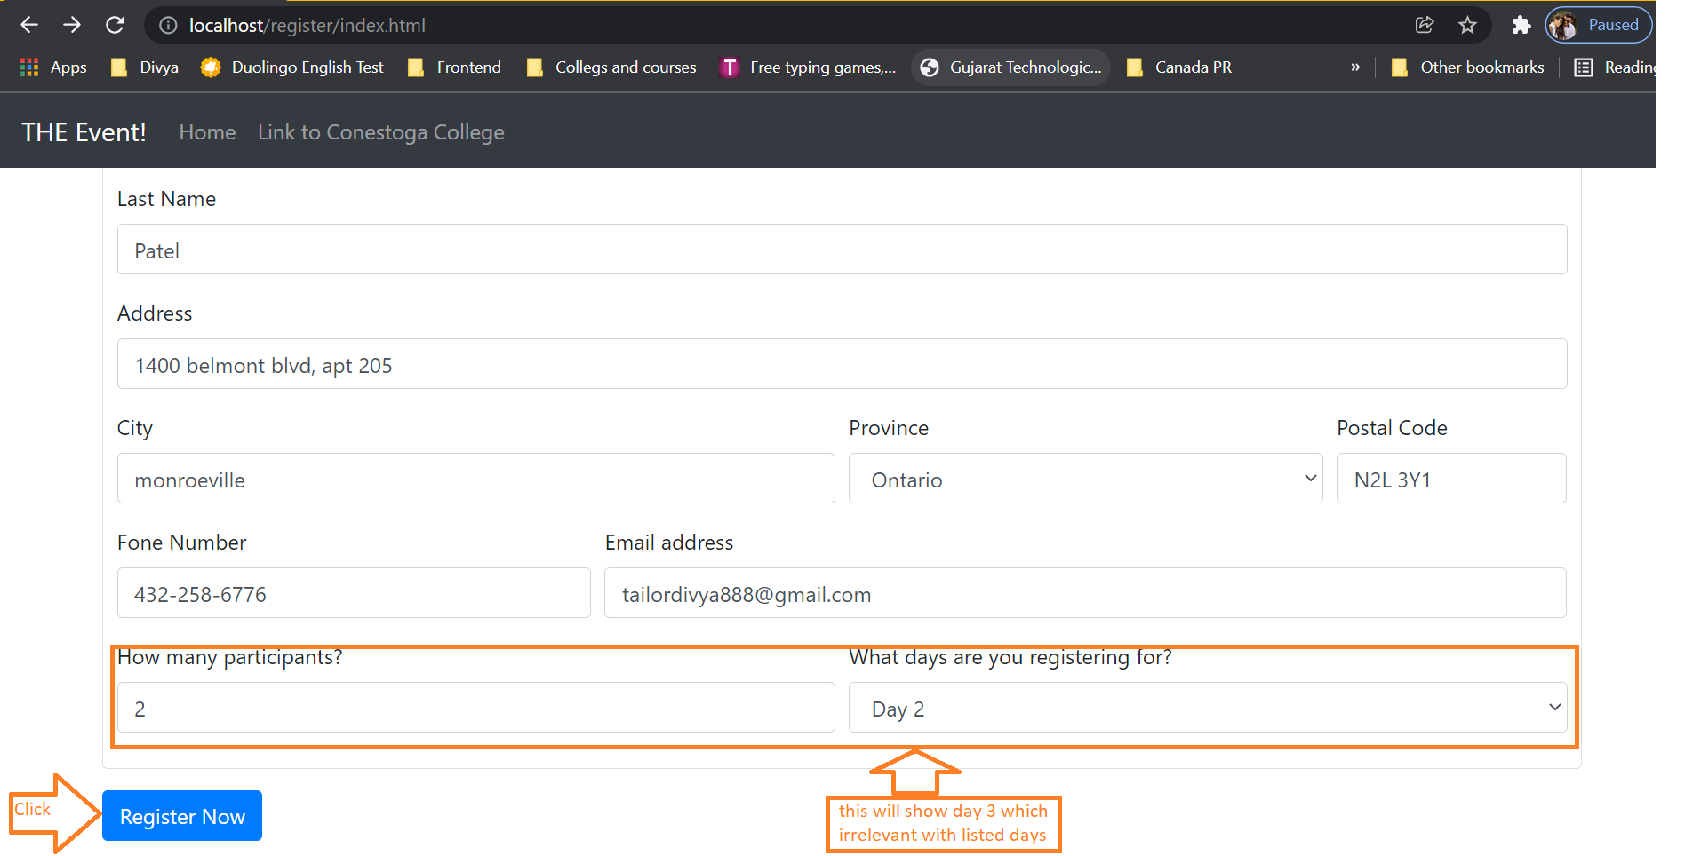

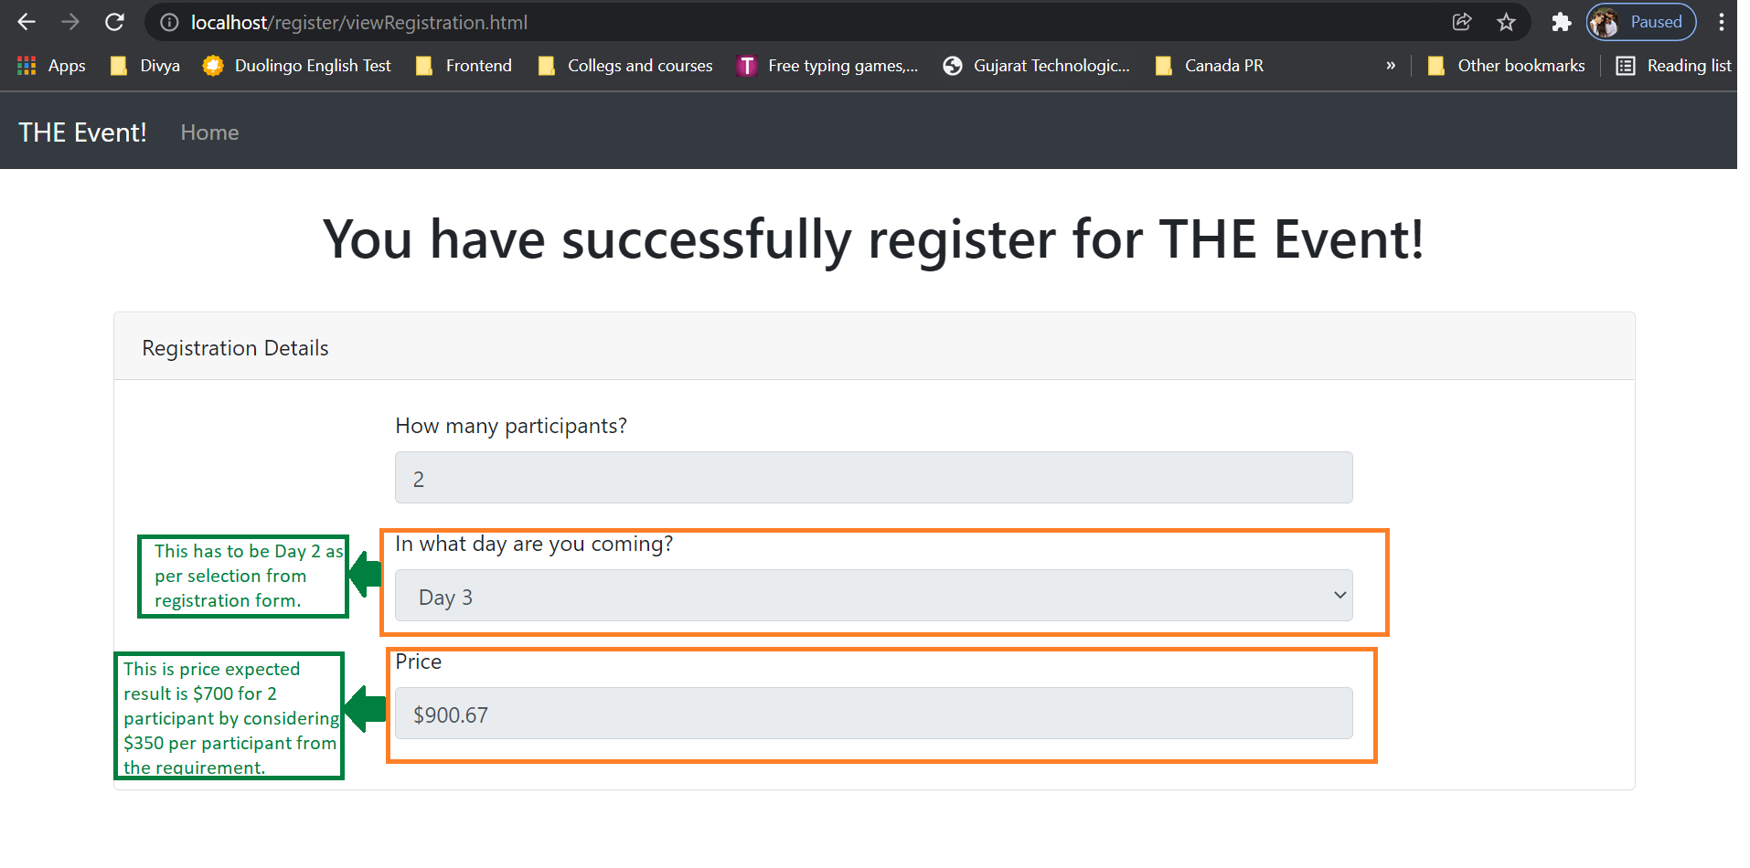

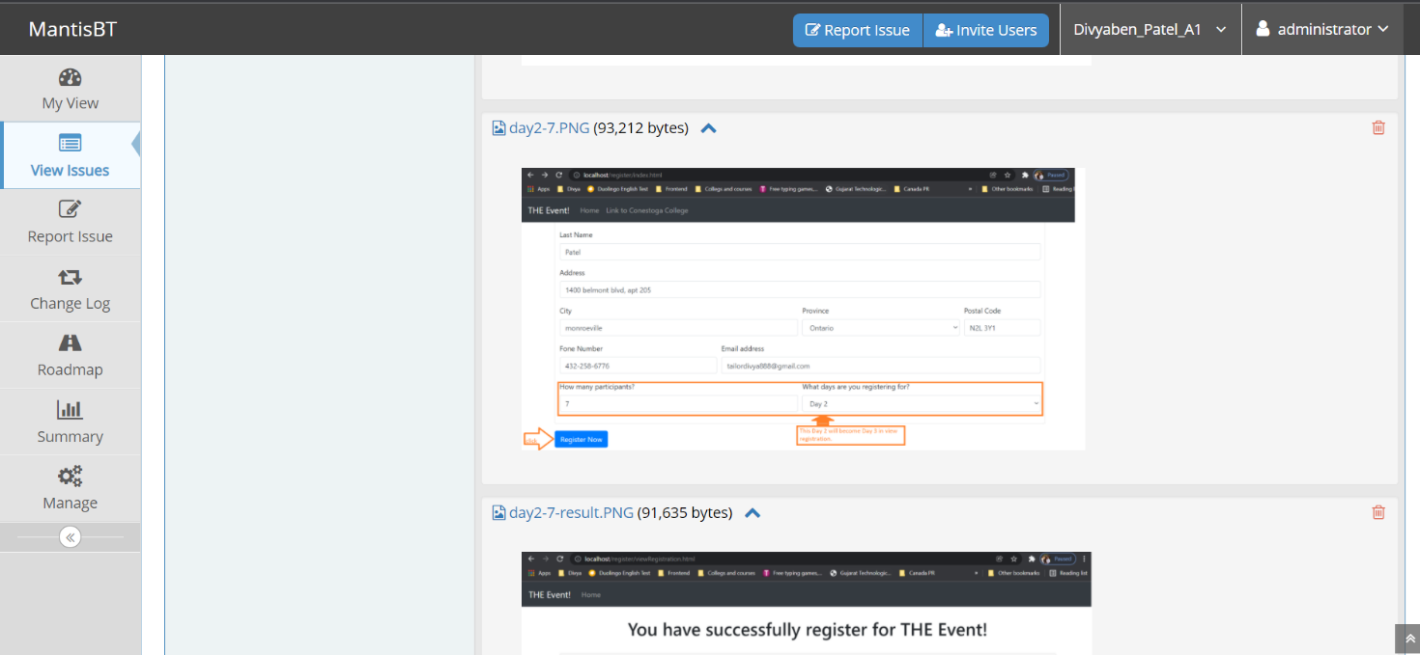

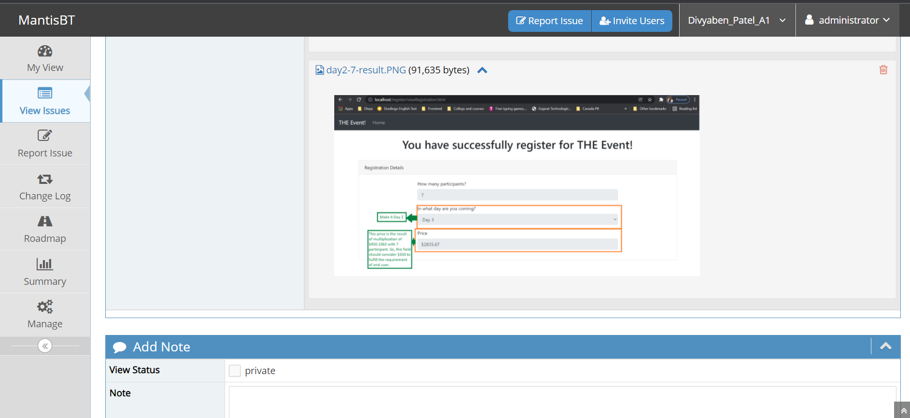

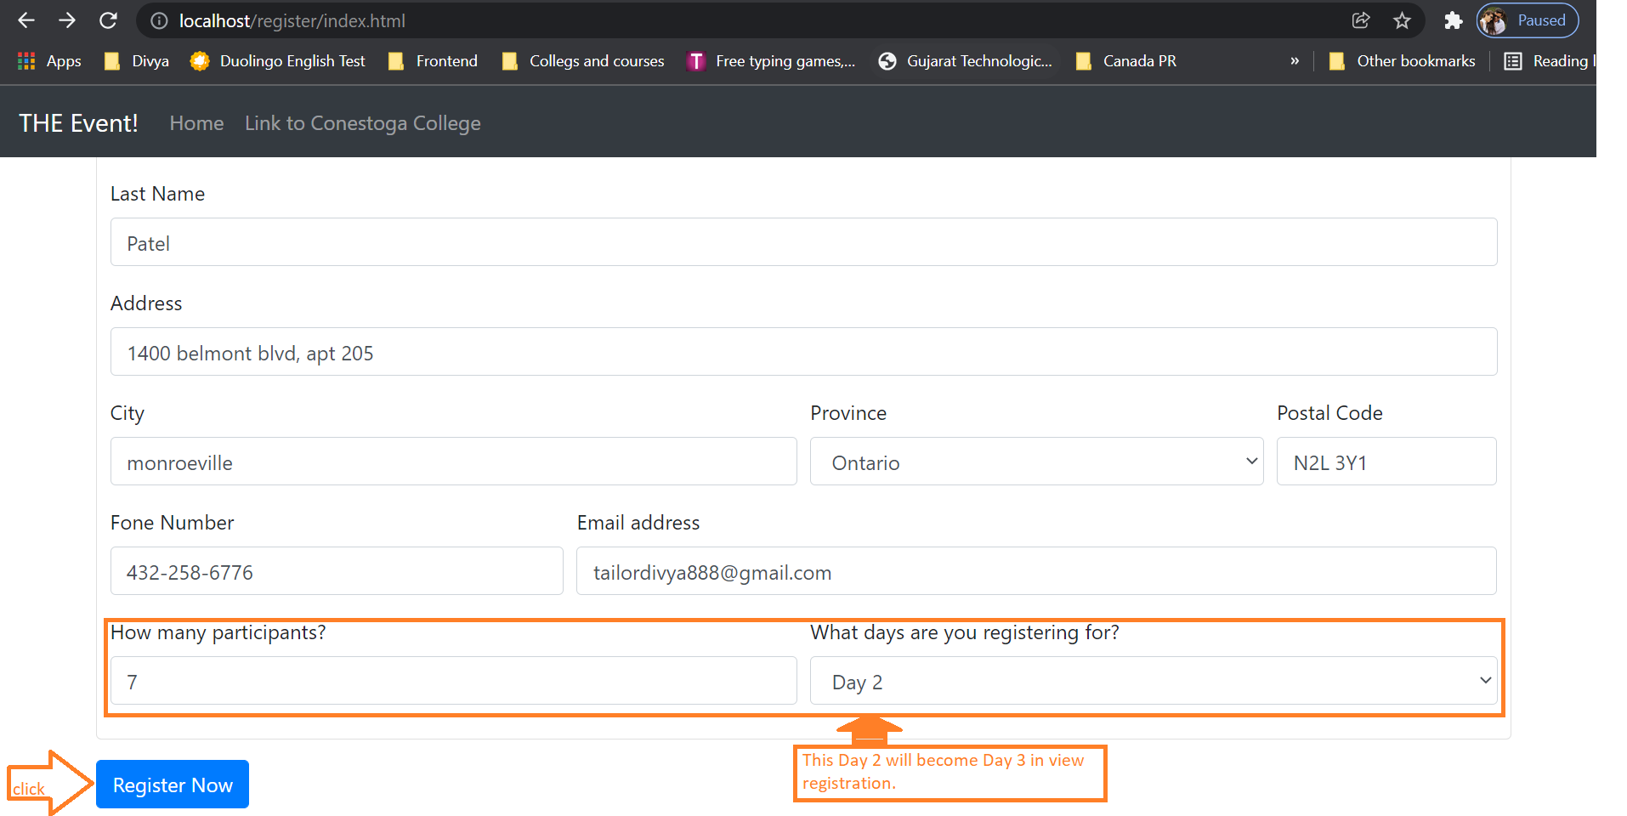

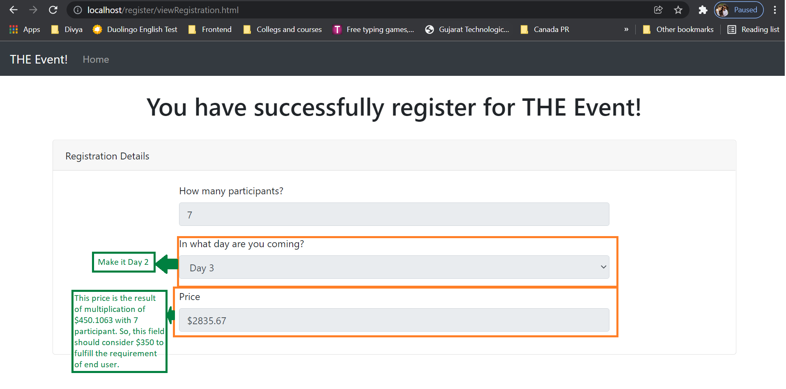

* 1. In the view registration page price for both days for participant 1 is extremely higher than expected price amount, which $750.

**Severity**: major.

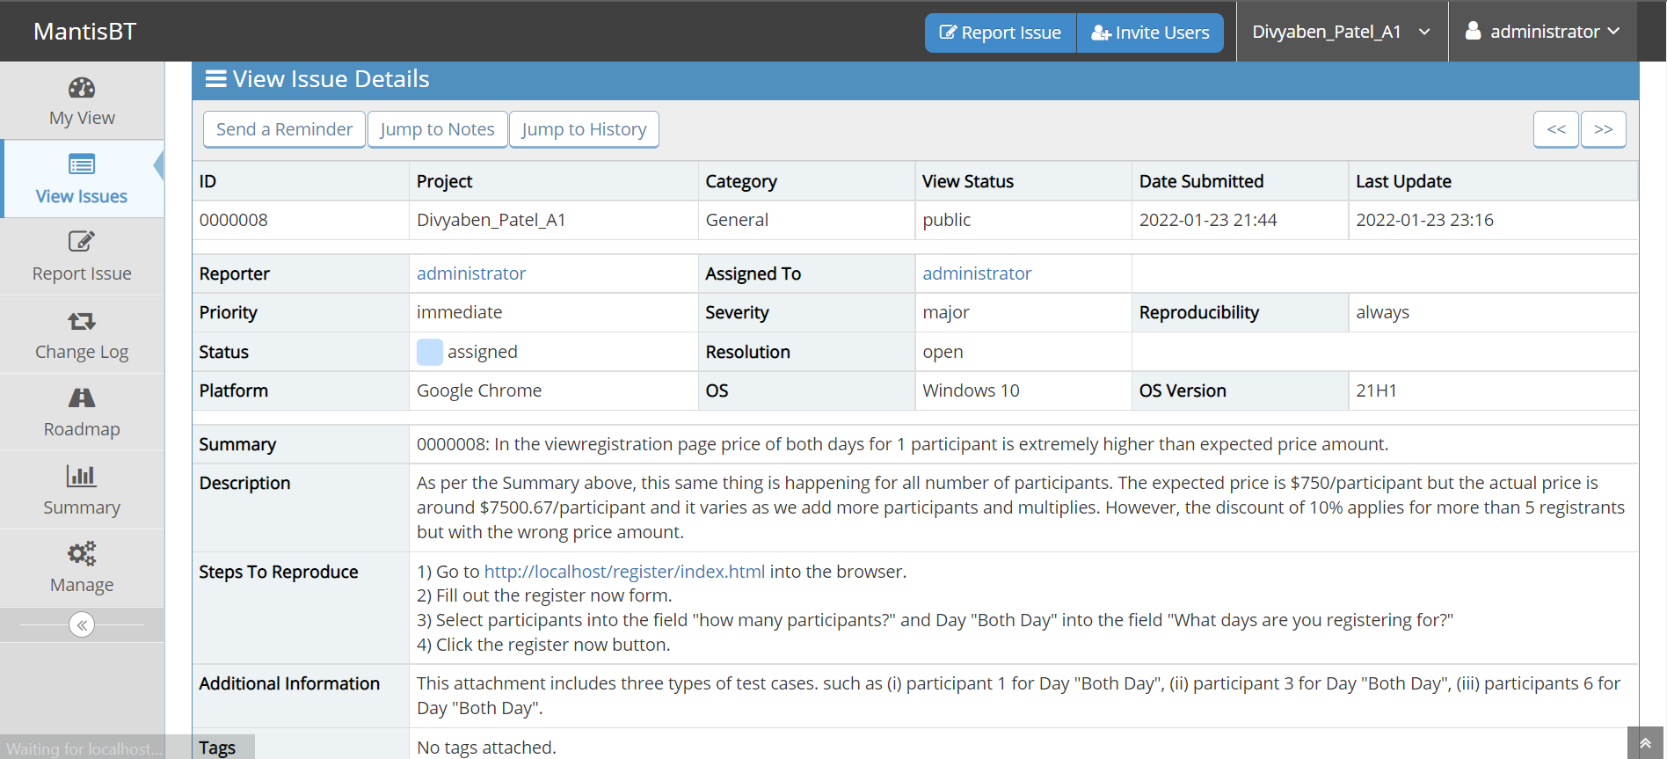

1.7.1 The below two images are for participant 1 who’s taking part in the events are on both days.

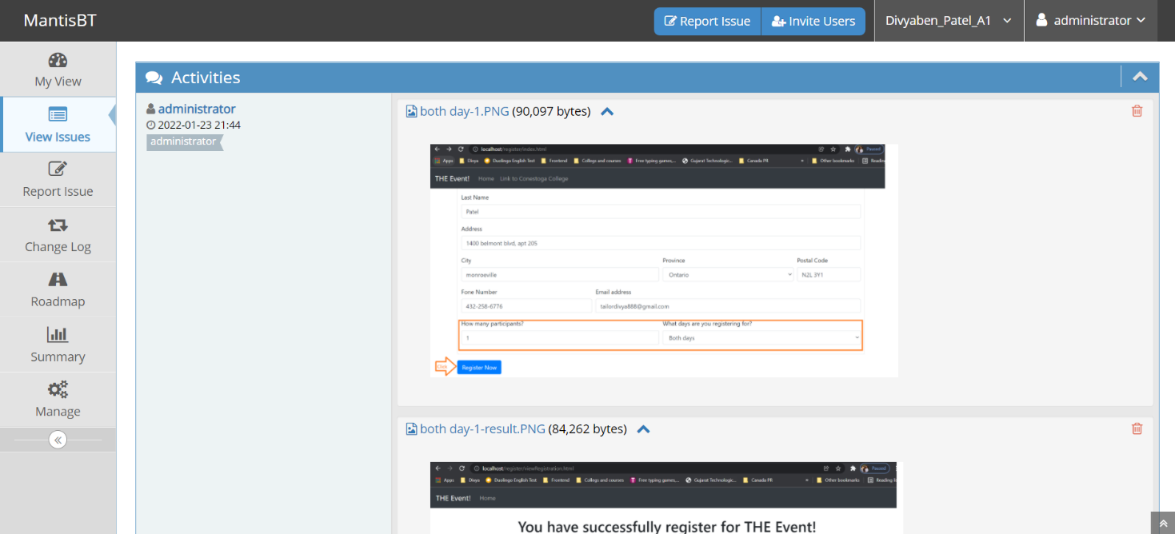

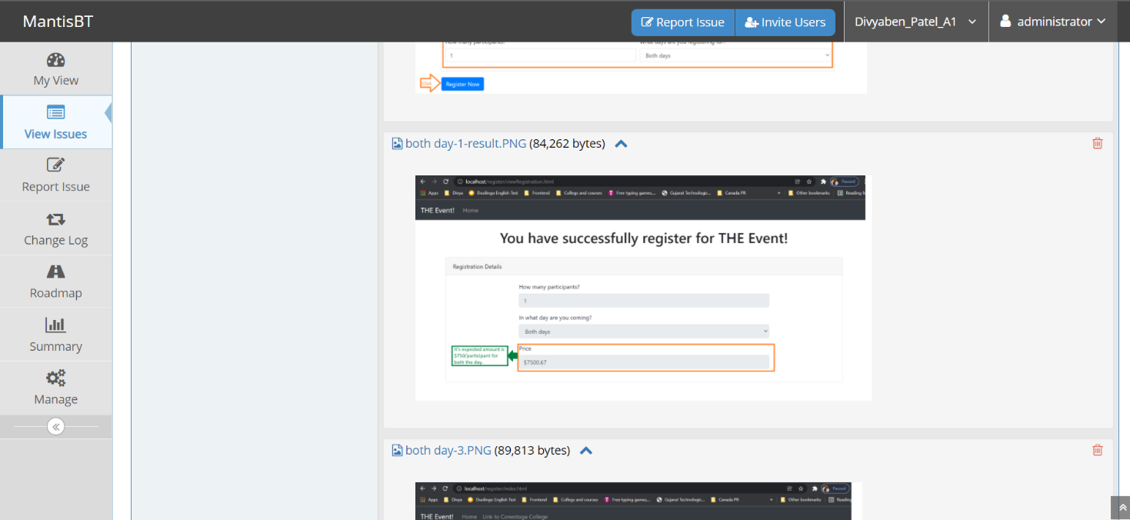

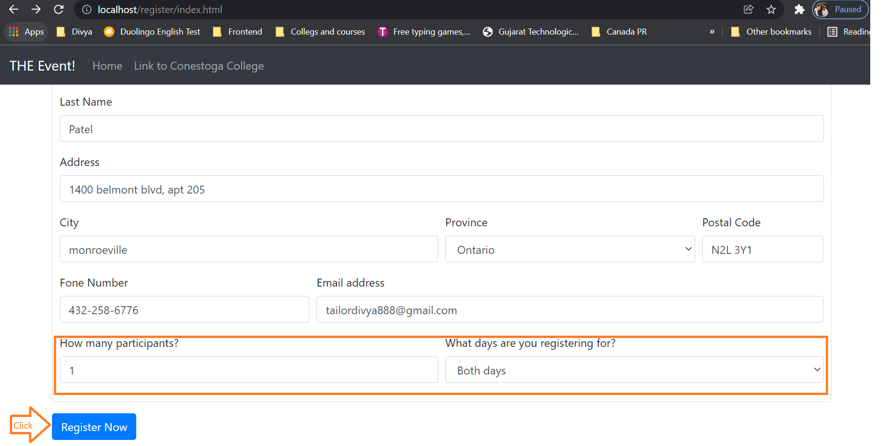

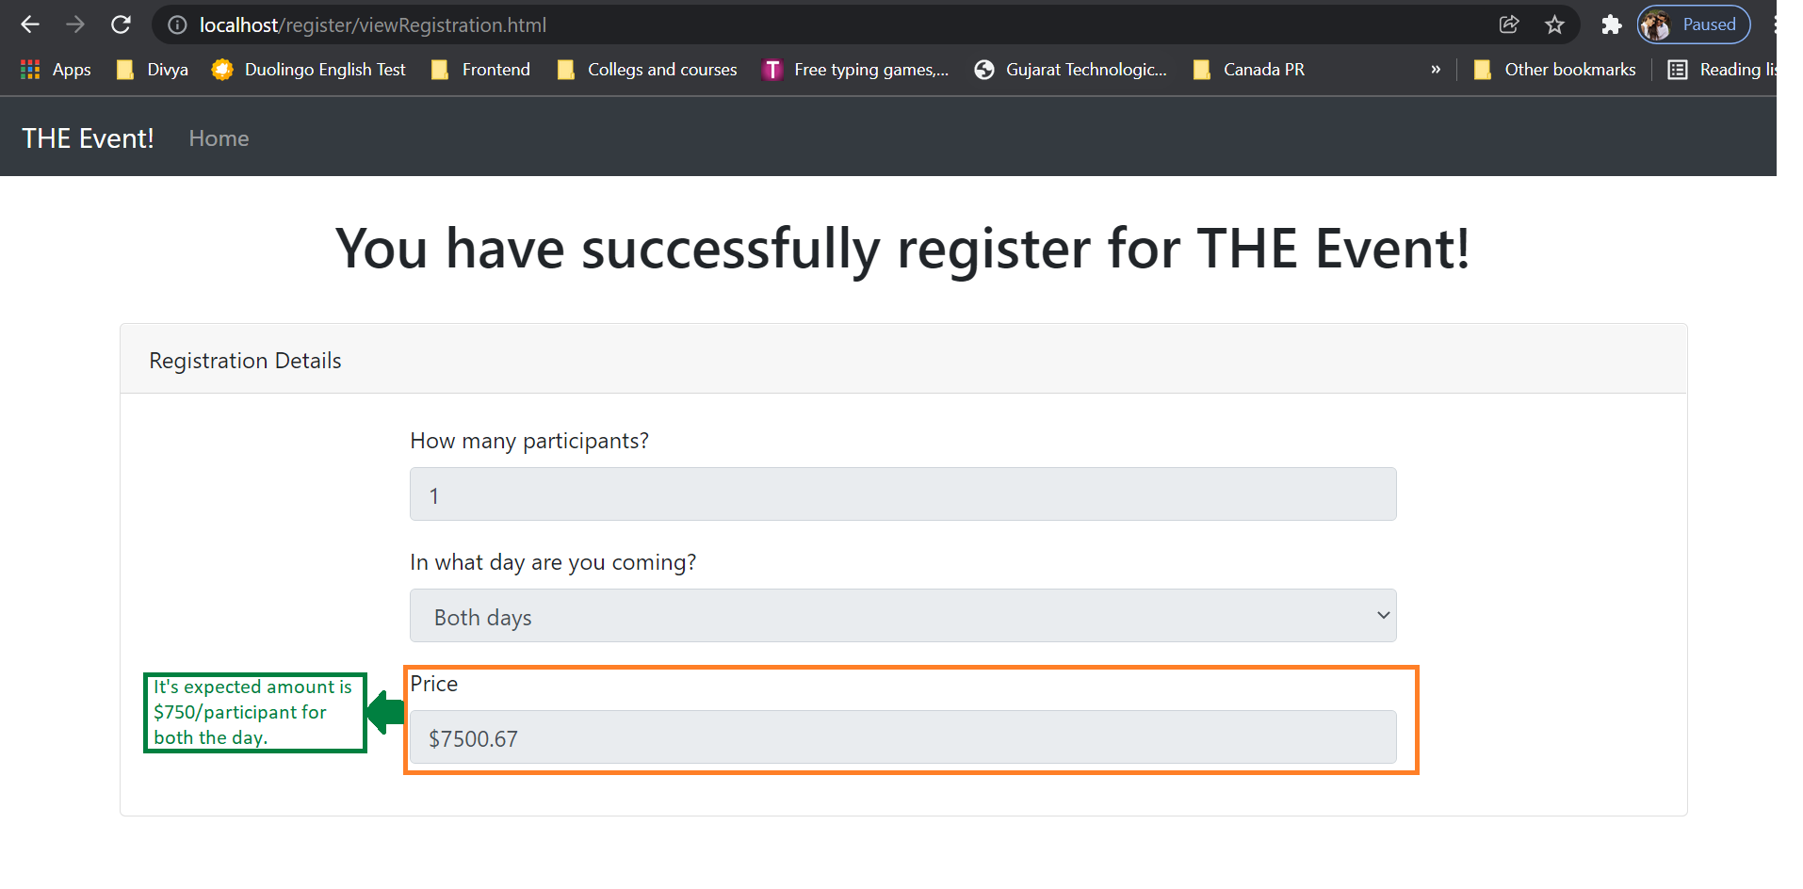

1.7.2 The below four images is for participant more than 1 who’s taking part in the events are on both days.

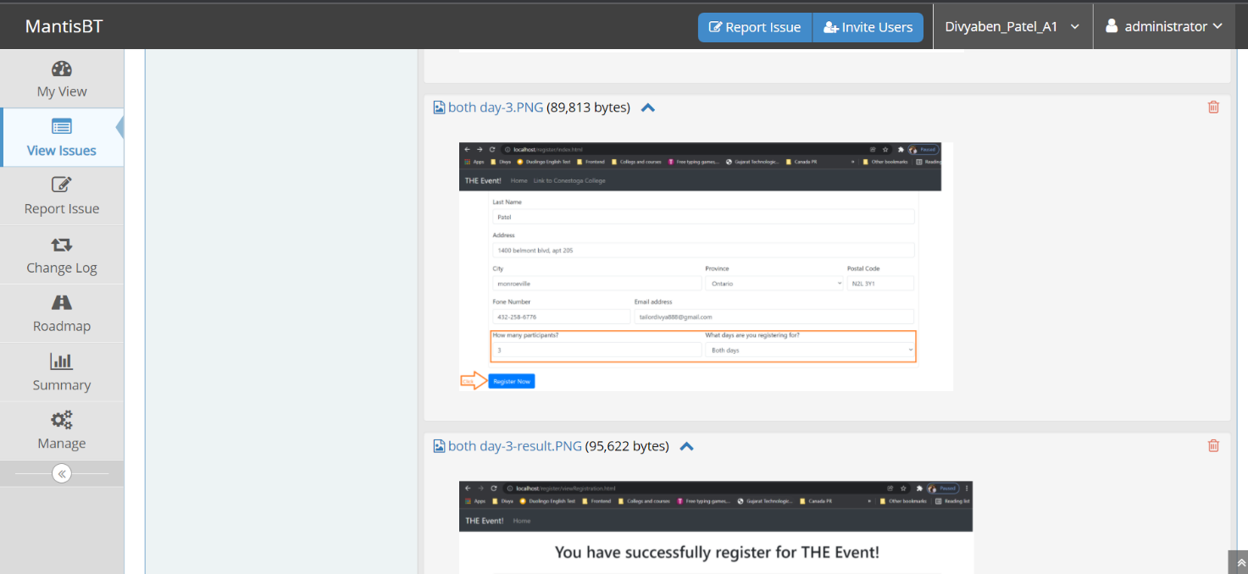

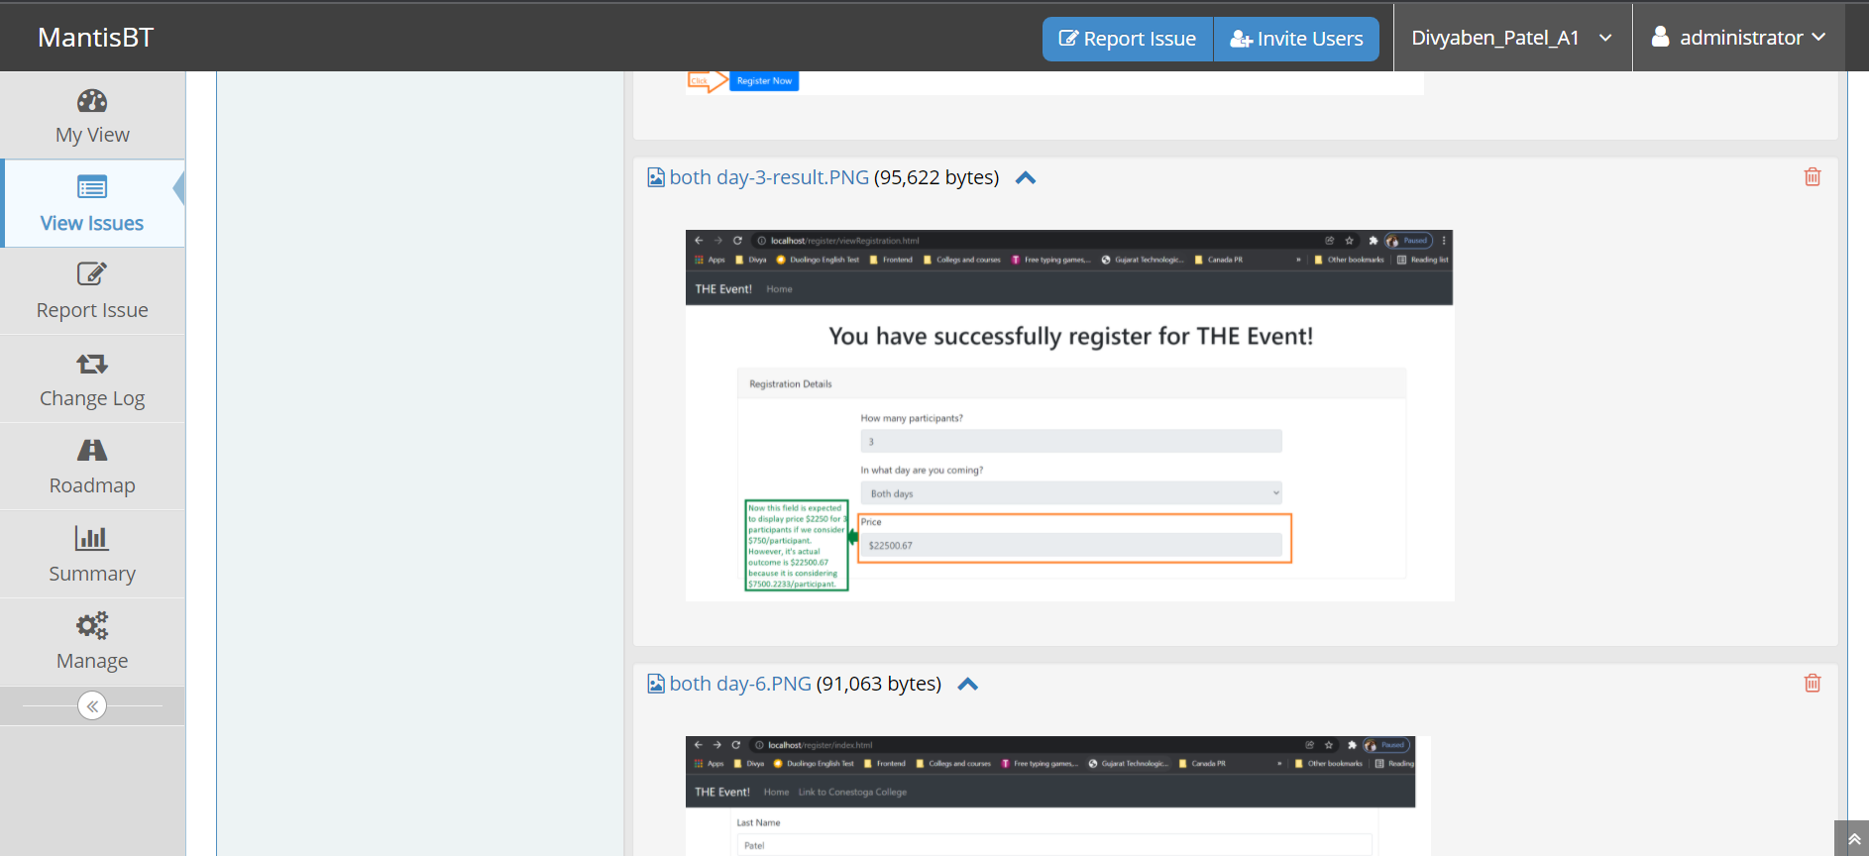

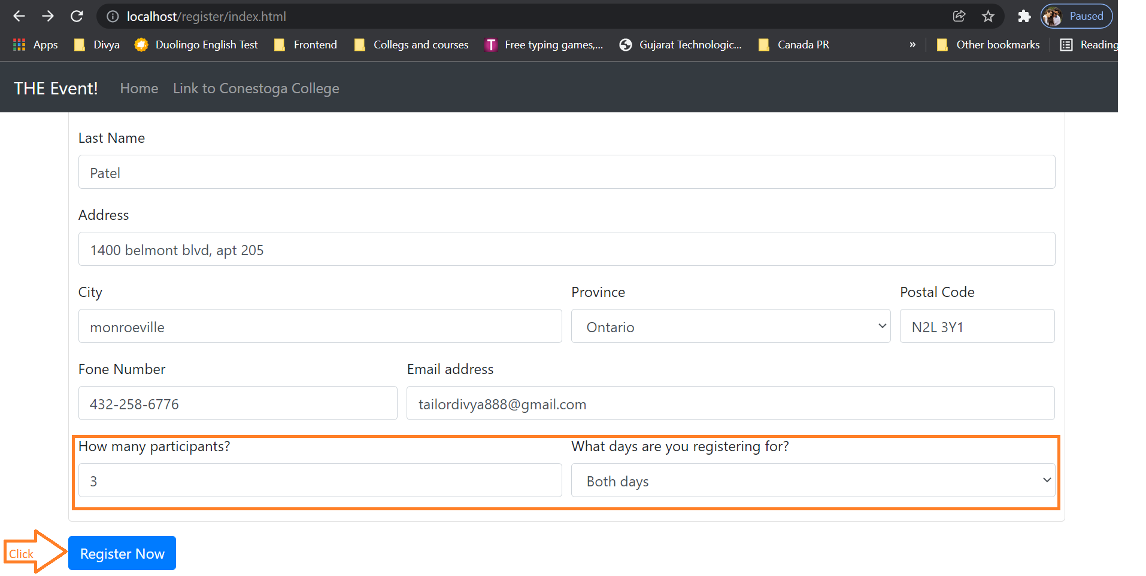

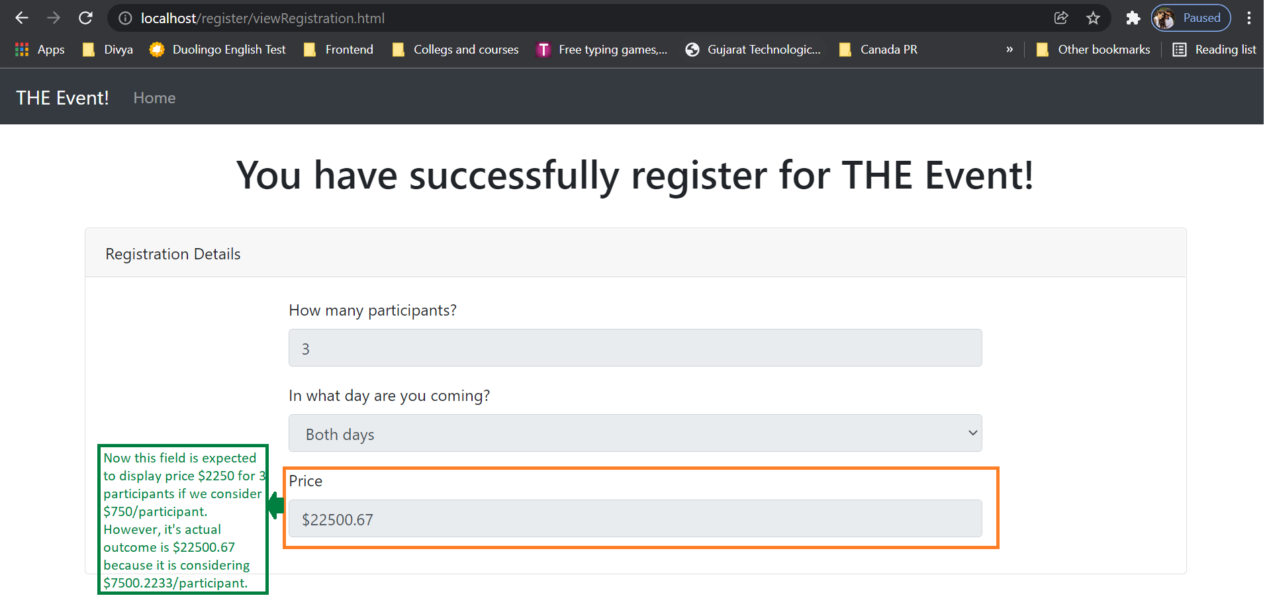

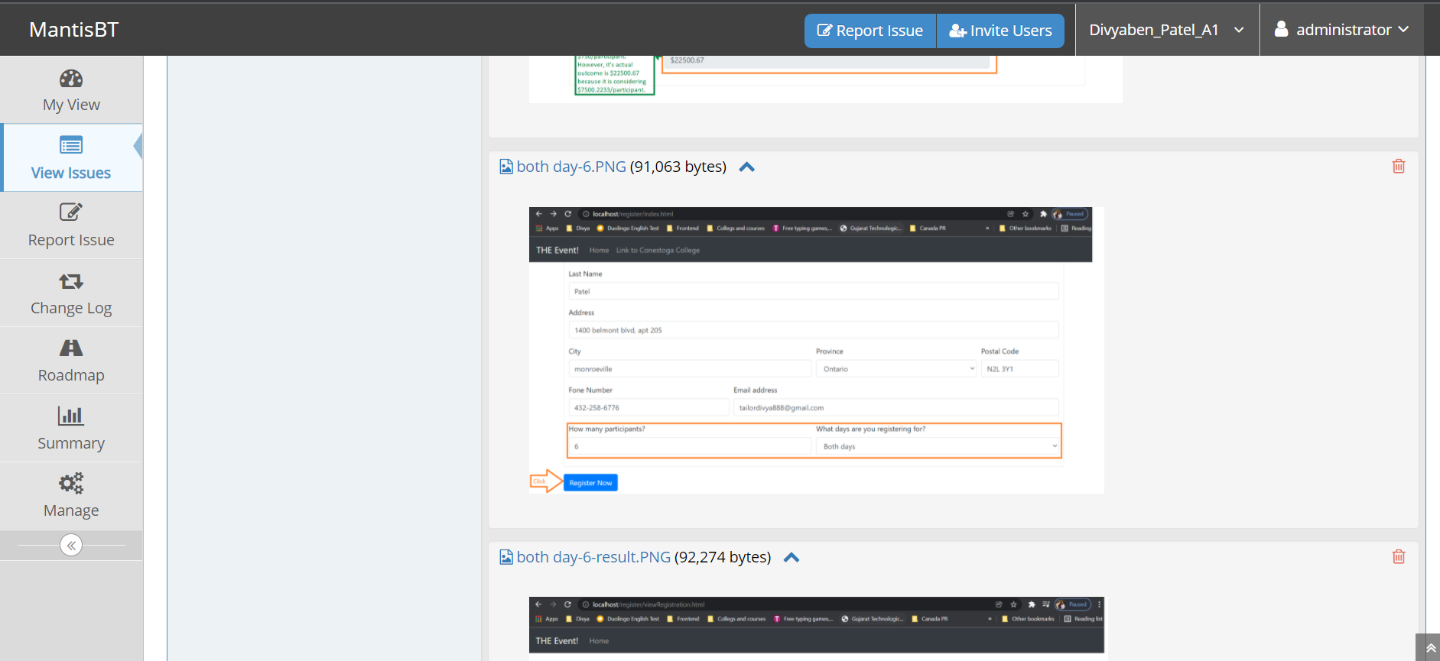

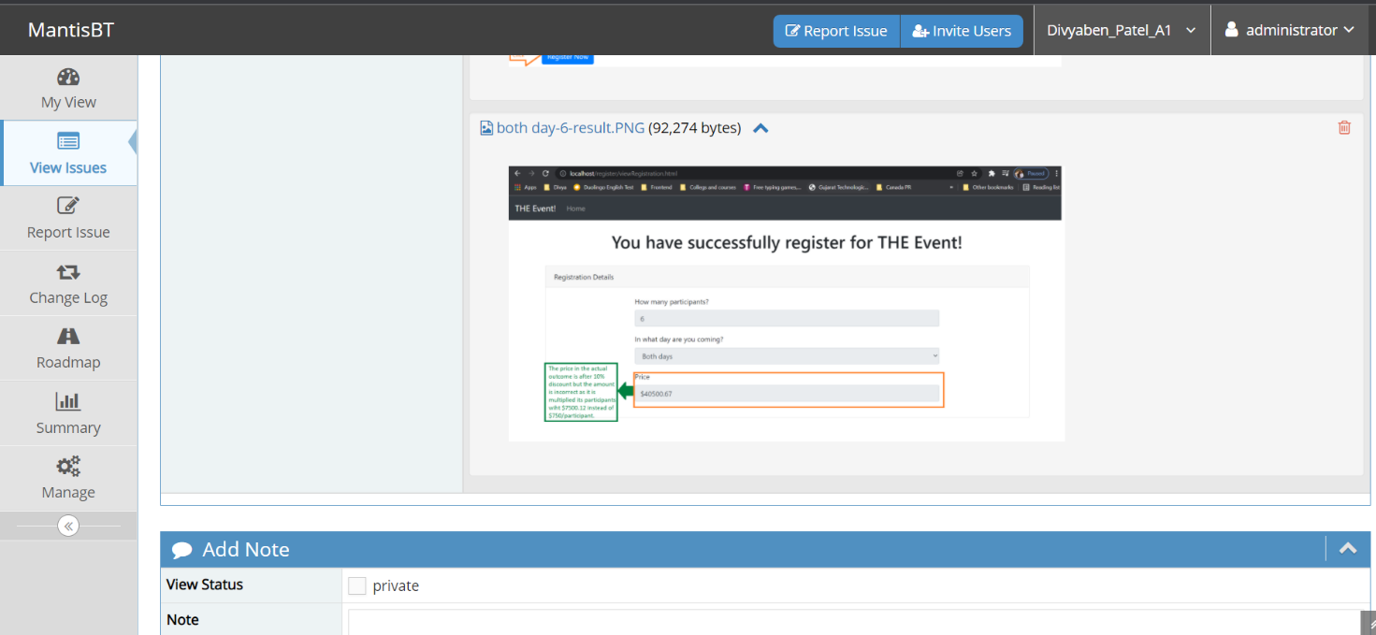

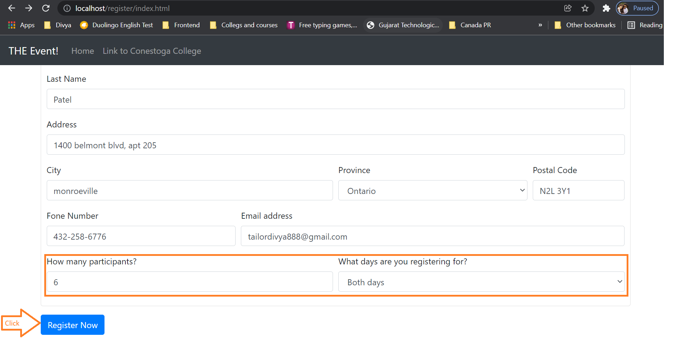

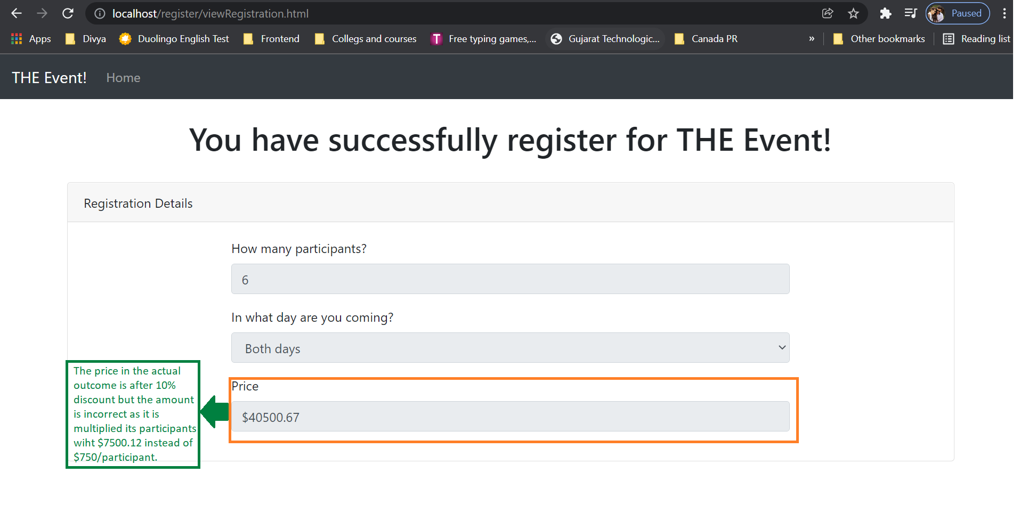

* 1. Postal code also accepting small alphabets such as this n2l 3y1 instead of only accepting capitalization of alphabets like N2L 3Y1.

**Severity**: minor.

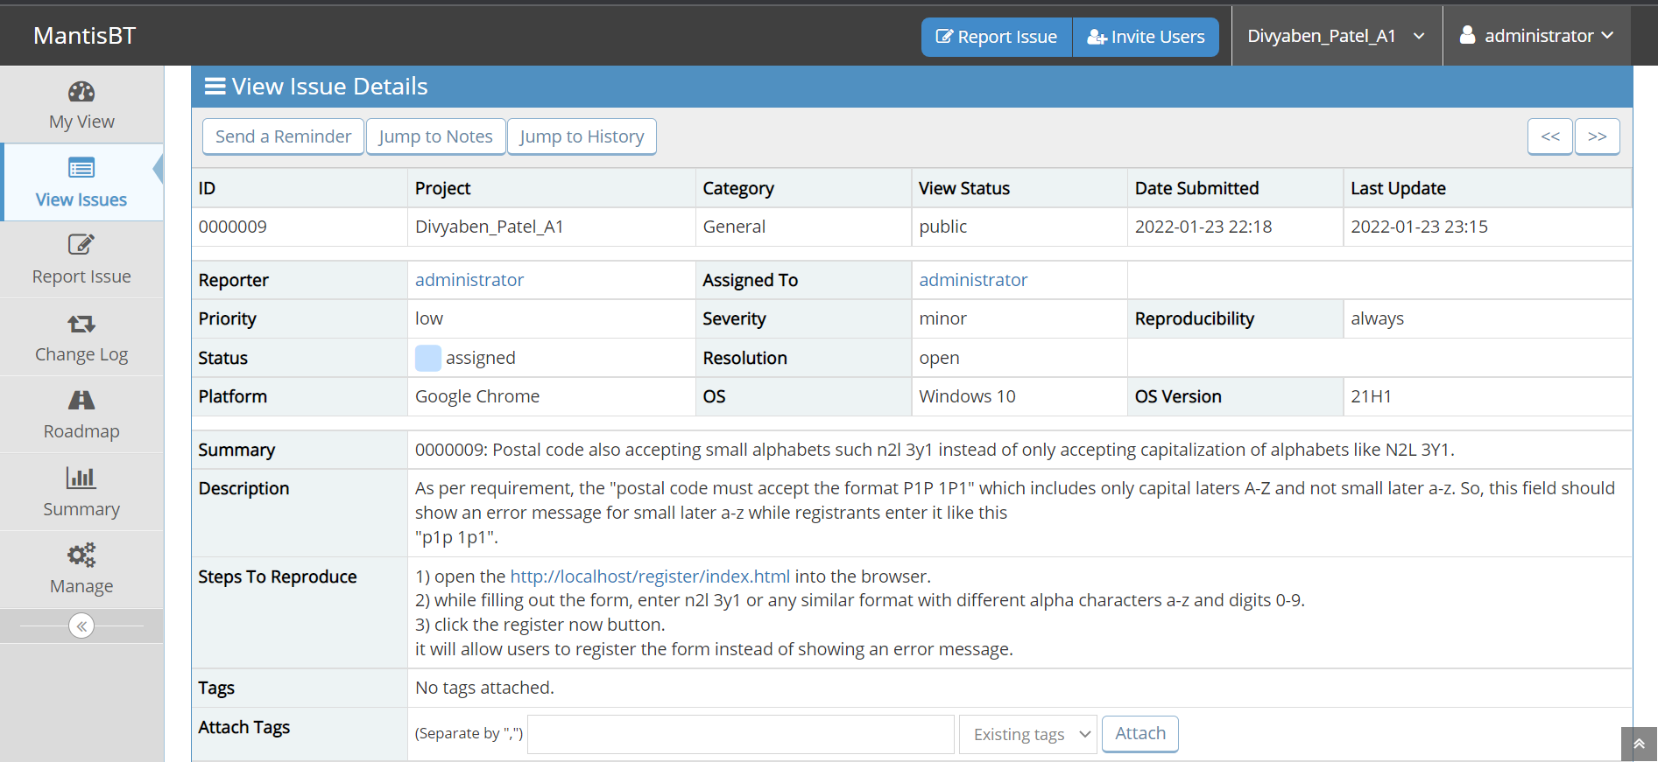

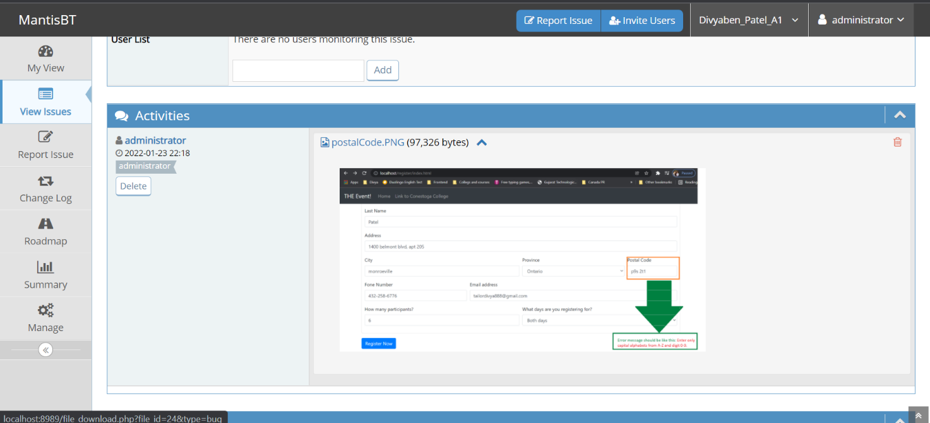

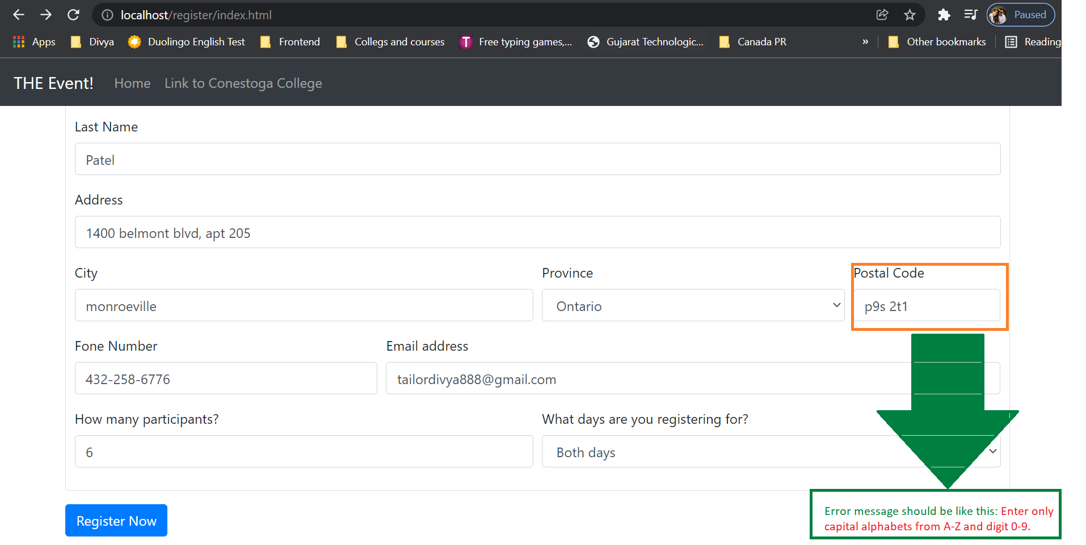

* 1. Back button is not present in the view registration page.

**Severity**: block

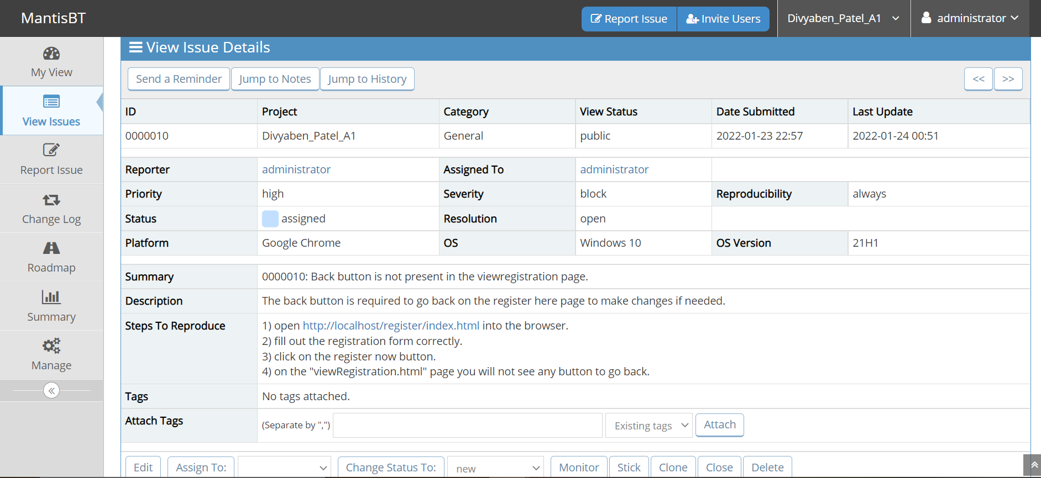

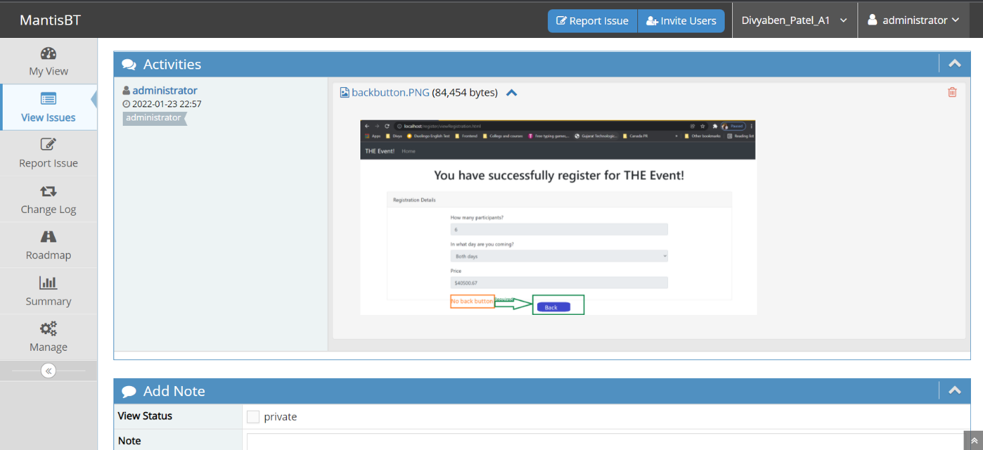

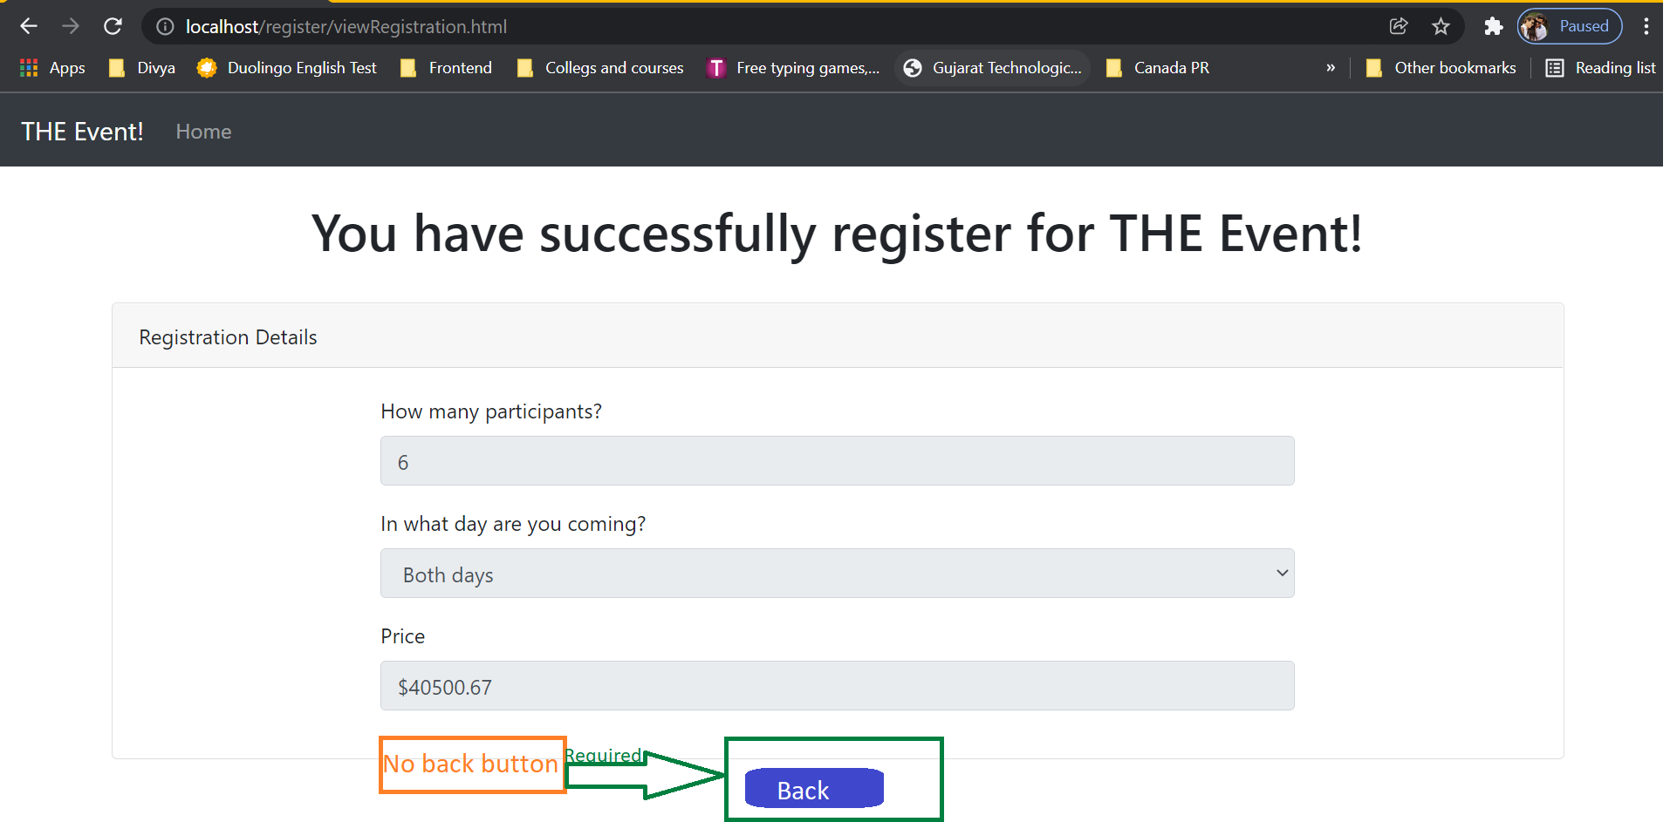

* 1. The below two images represent that, after clicking on the home link, which is on the index.html/register here page flow is crashed.

**Severity**: crash.

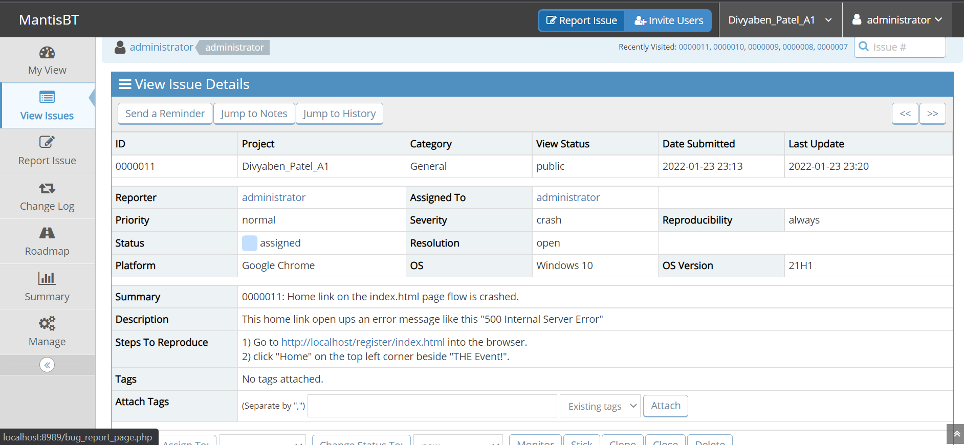

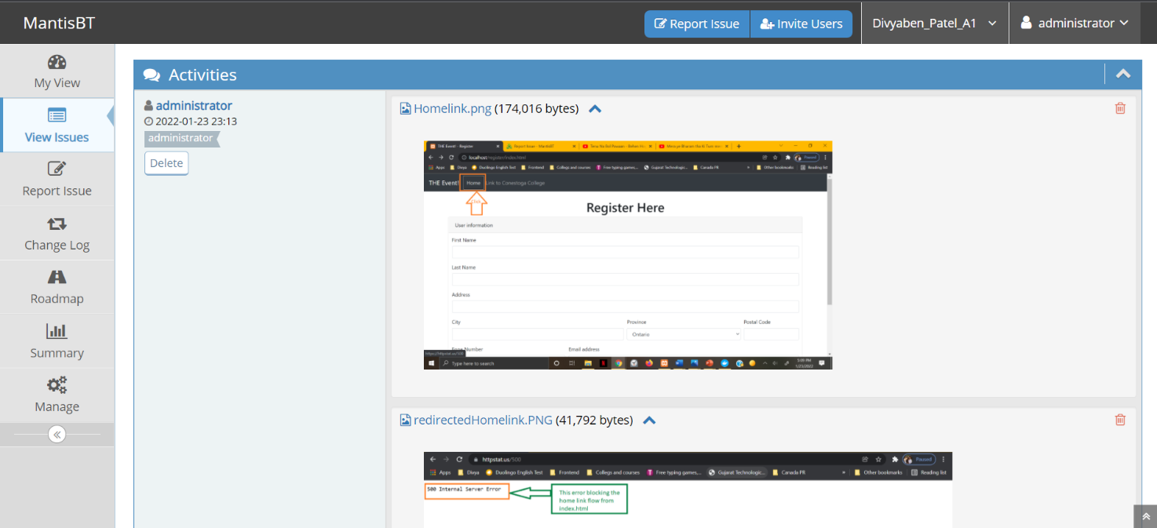

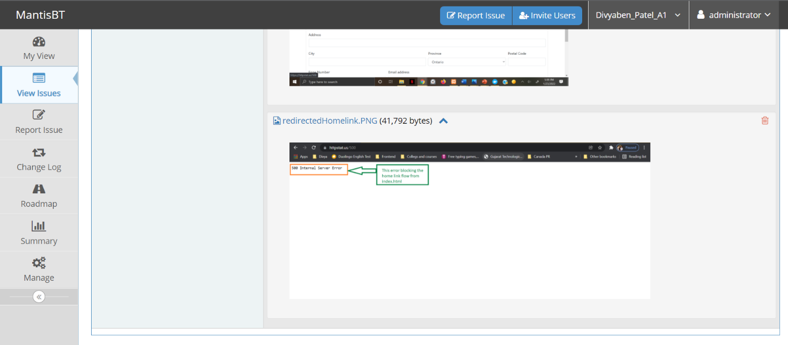

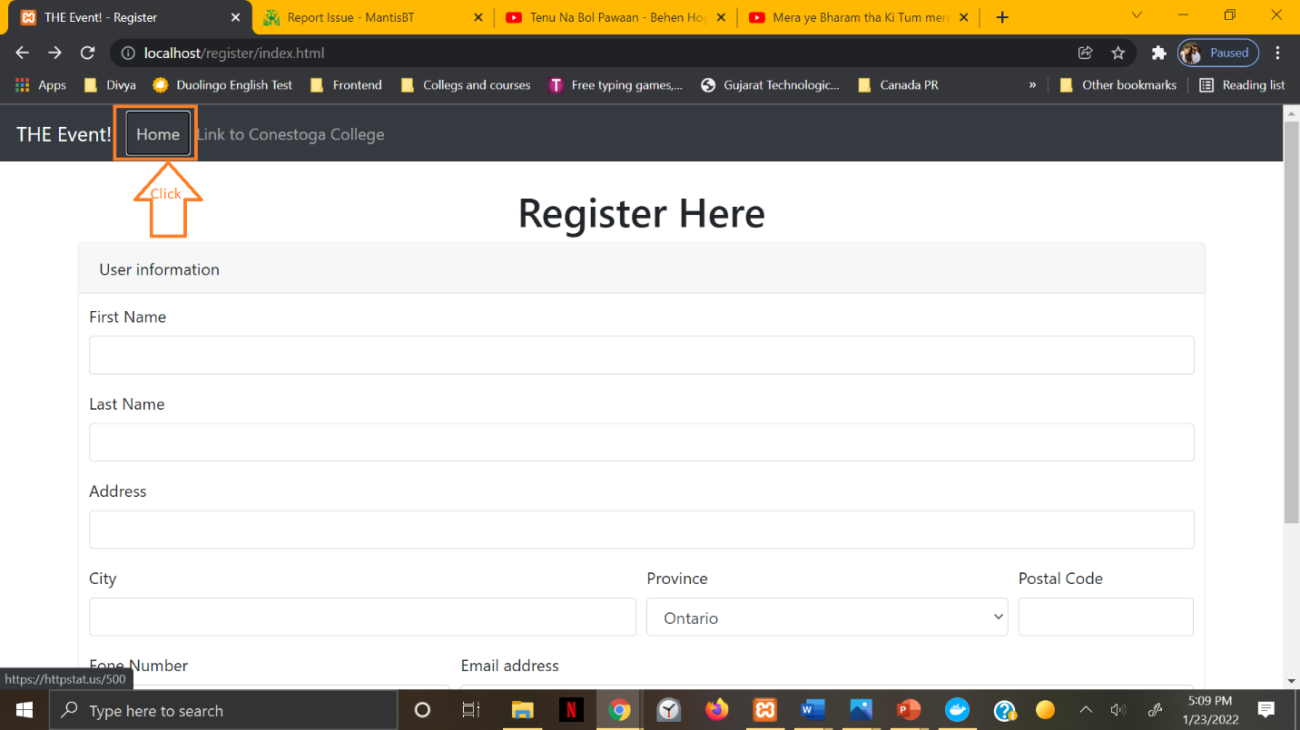

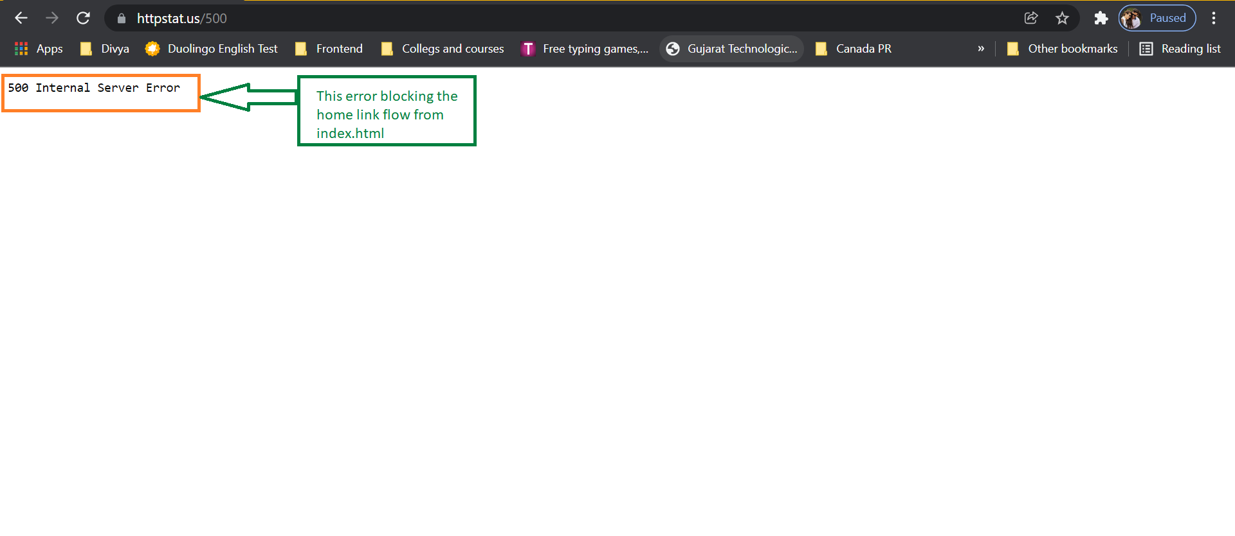

* 1. First name and Last name allowing everything such as digits and special characters with alphabets.

**Severity:** minor**.**

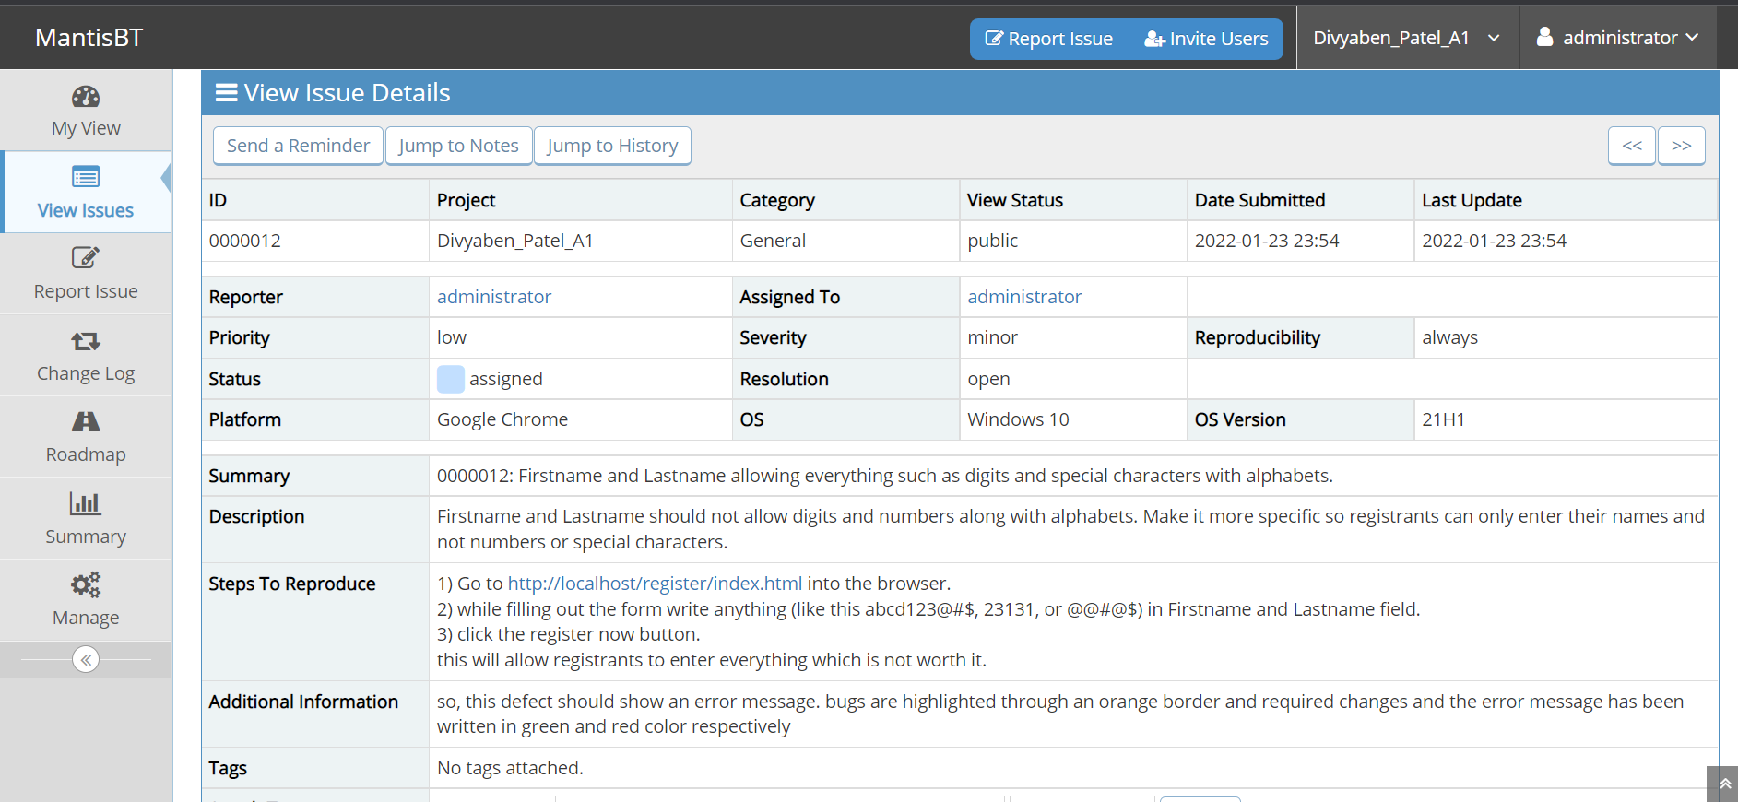

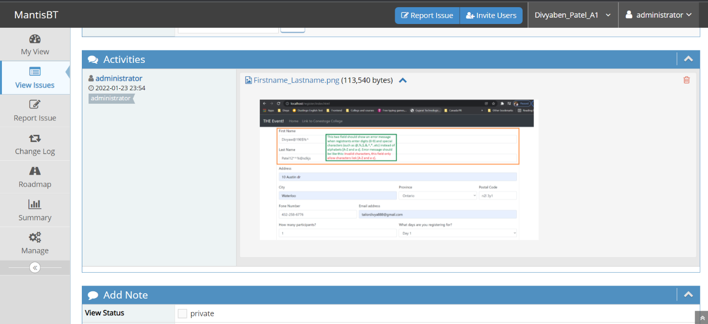

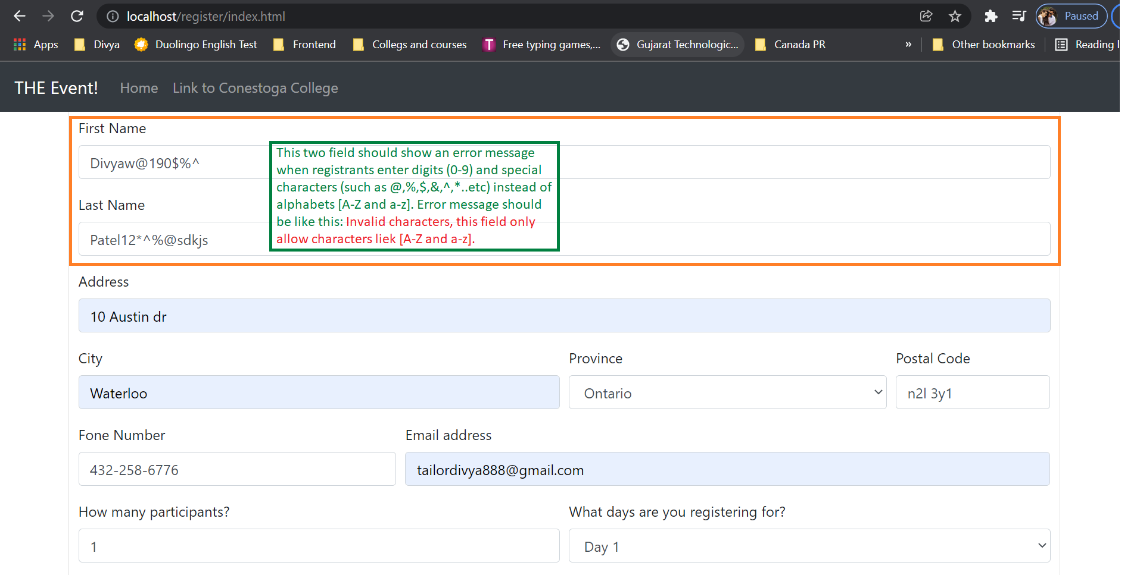

* 1. The below image is to show feature/enhancement for end user’s safety to pay for the events. Add payment method after filling the form and viewing registered information and popup confirmation message and final submit.

**Severity**: feature.

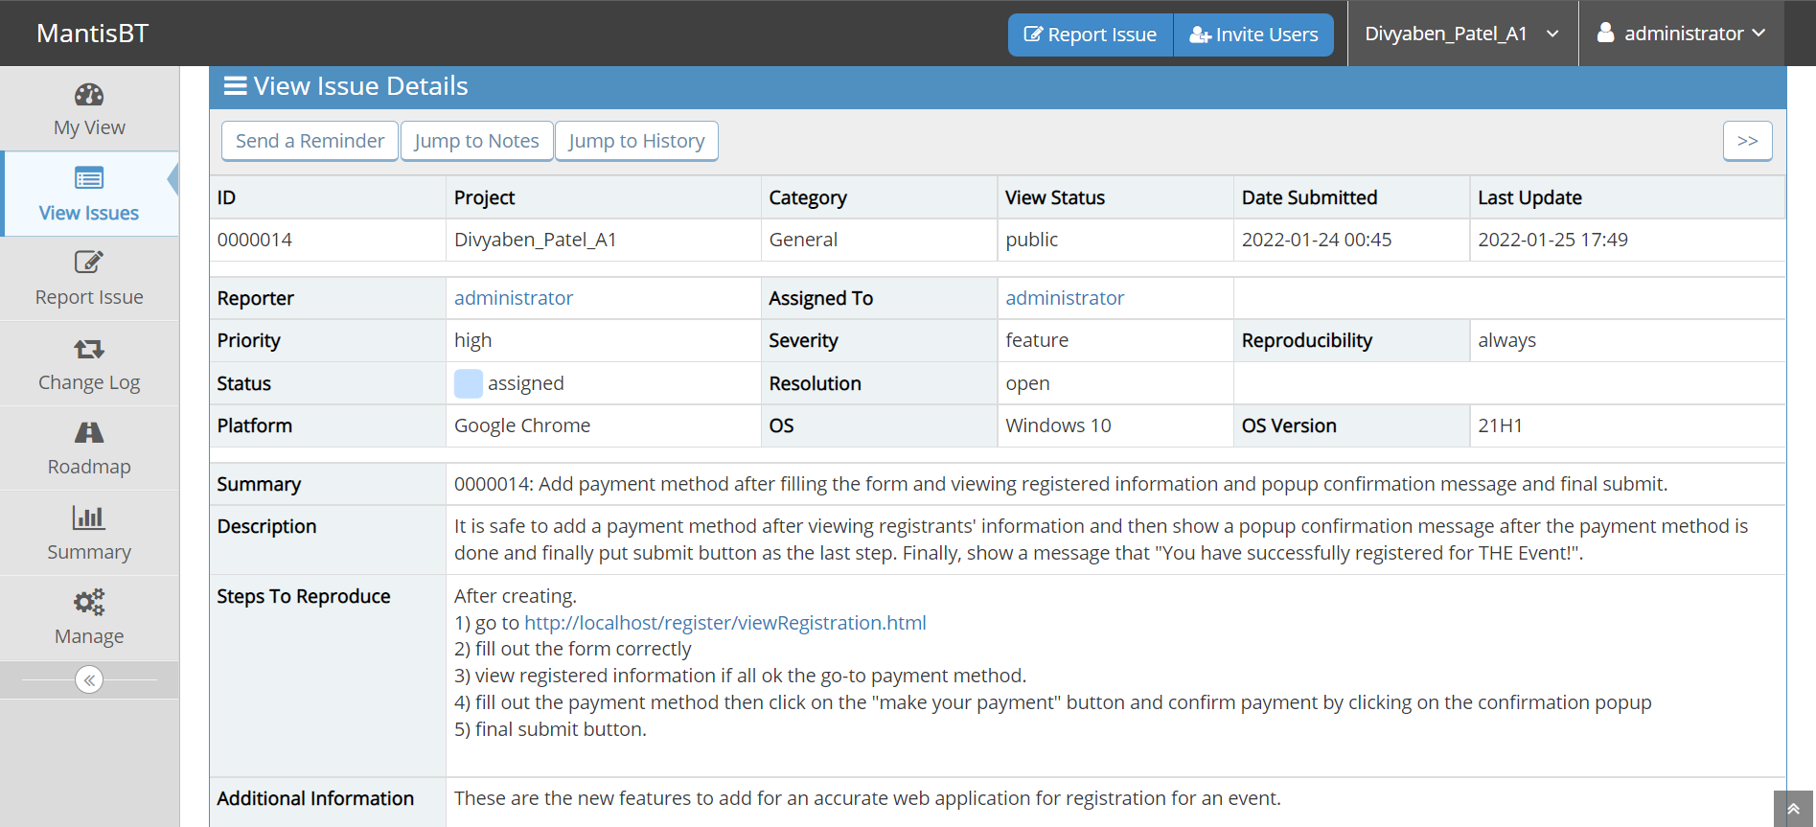

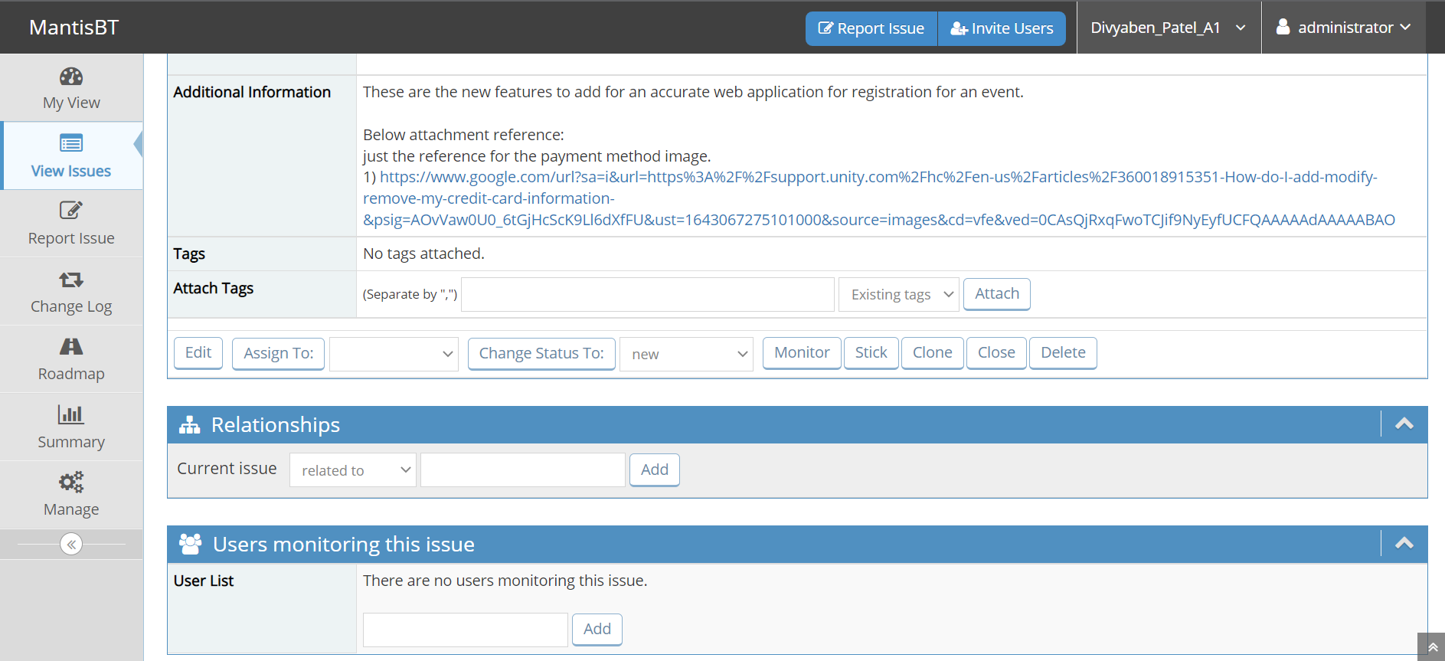

Image reference: (i).

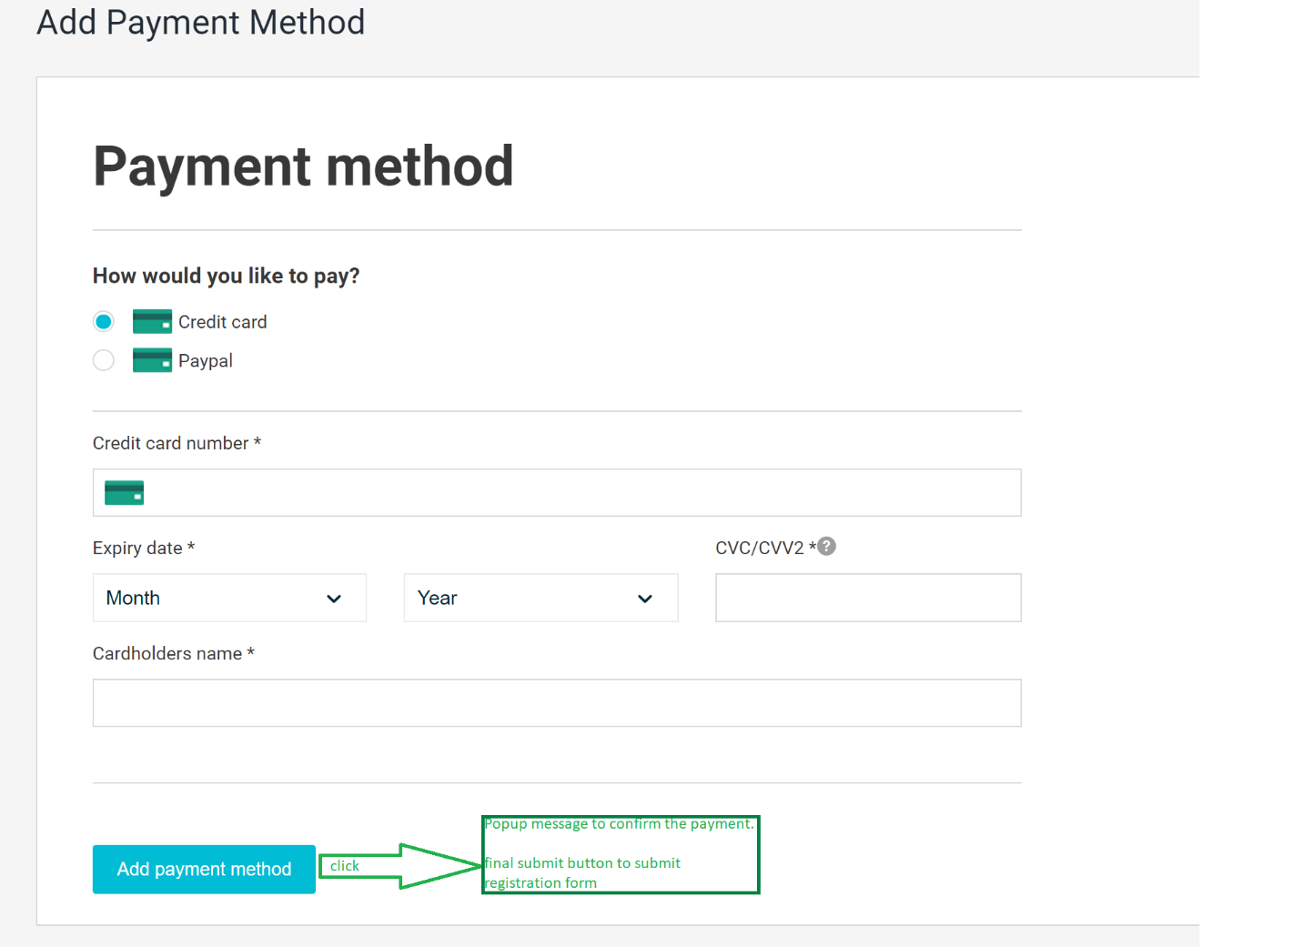

* 1. Provide red star (*) sign for all mandatory field in the registration form.

**Severity**: feature.

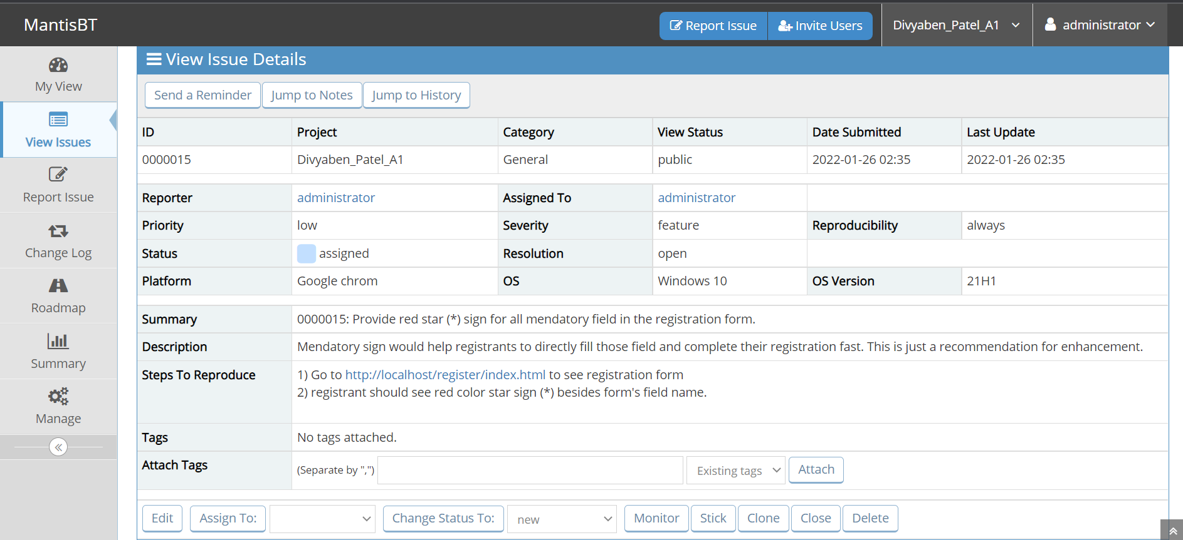

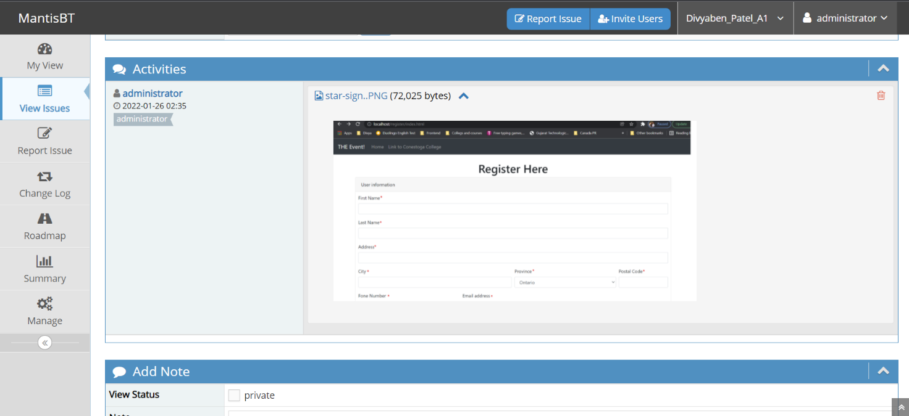

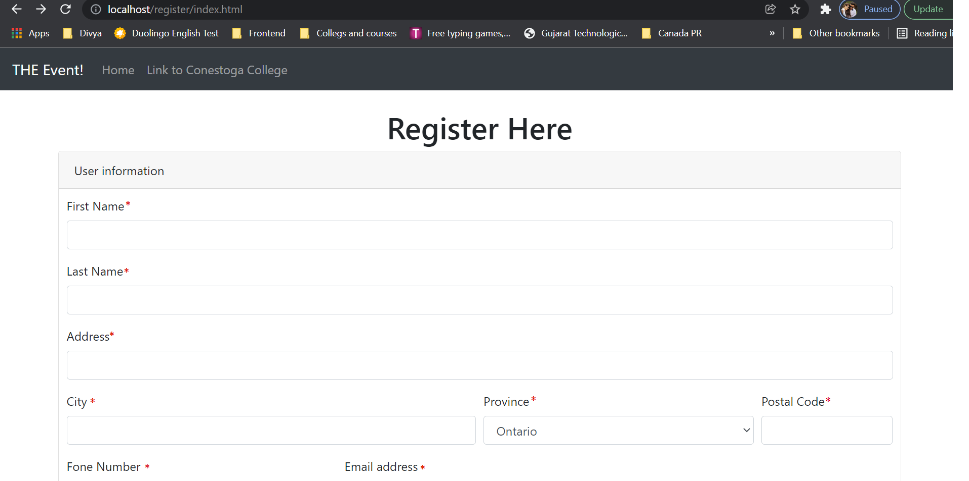

* 1. Email field allowing all the invalid format.

**Severity**: minor.

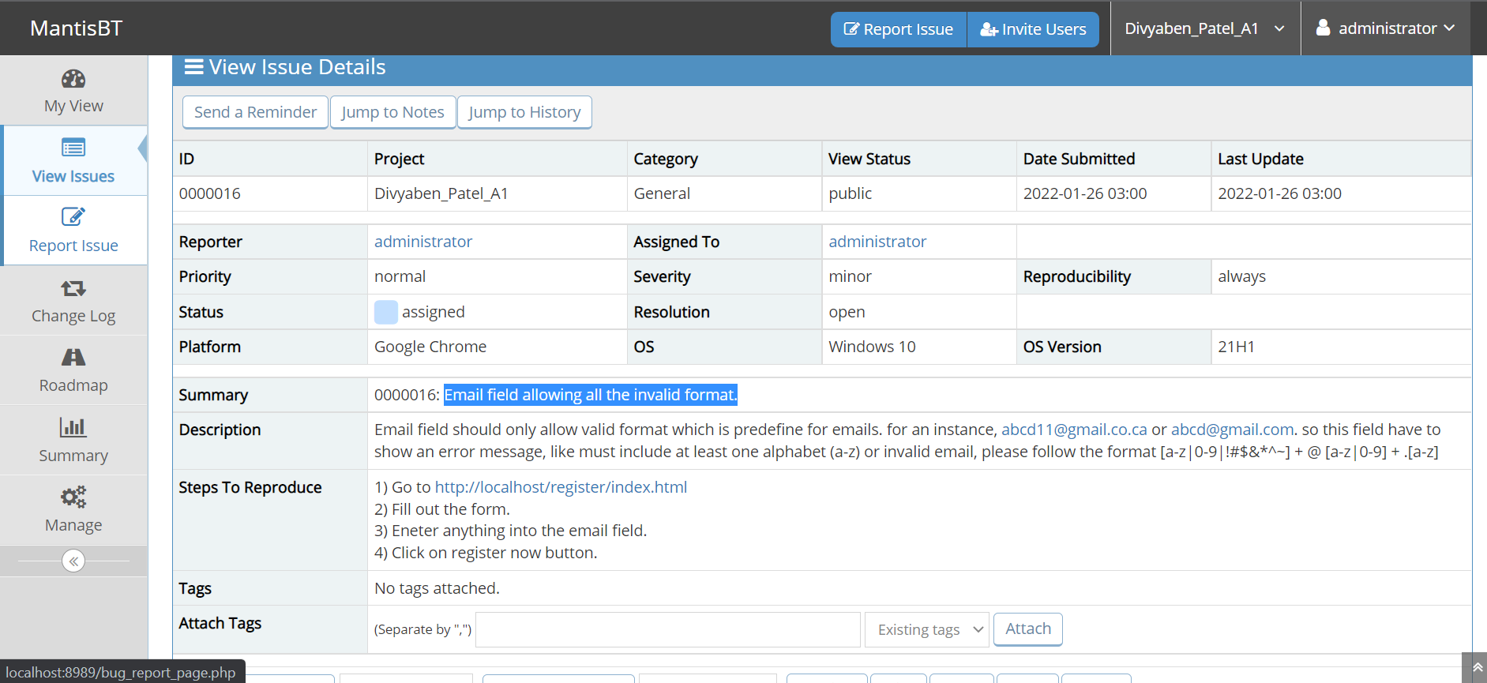

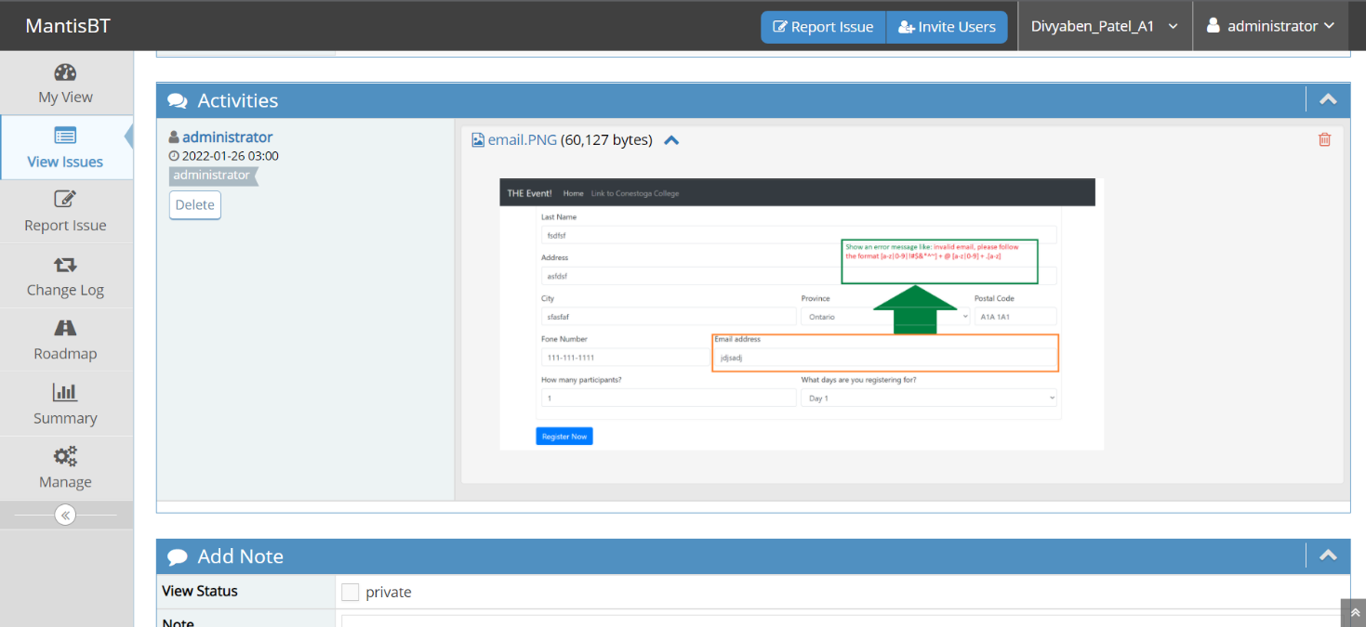

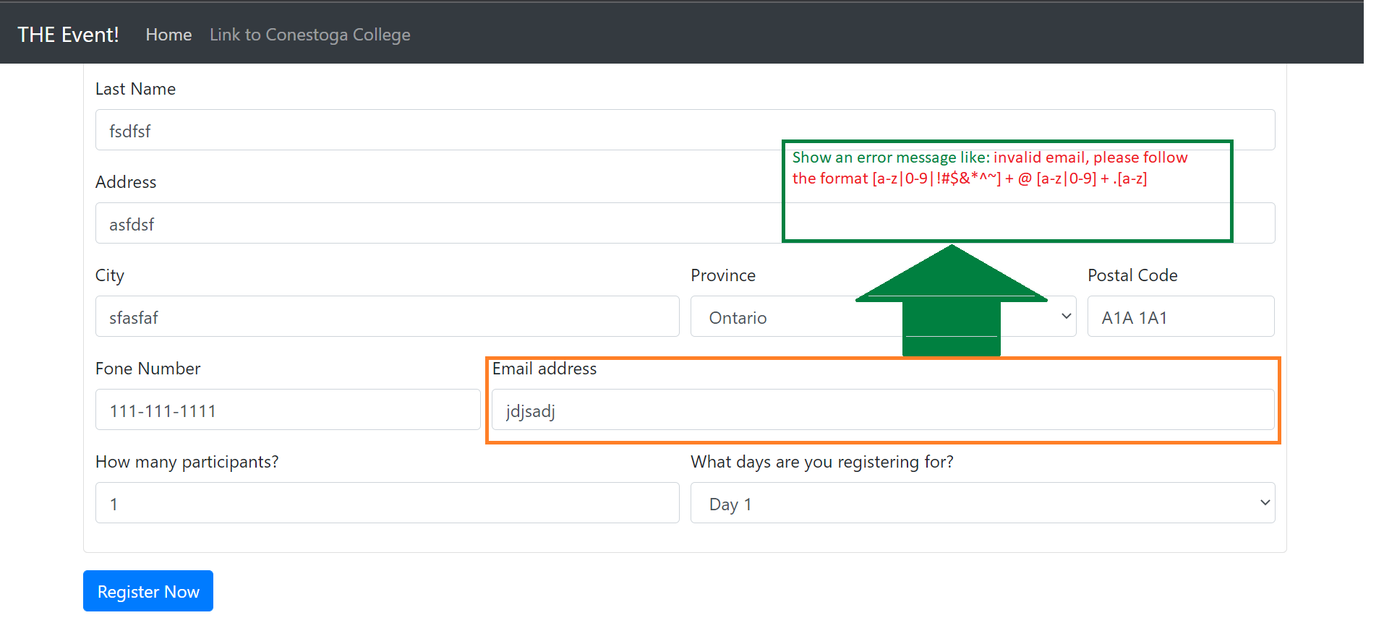

2) Screenshots of “summary” and “summary – by severity” reports of the defects that were logged in MantisBT.

2.1 The images given below are the images of summary of defects that are logged into the MantisBT.

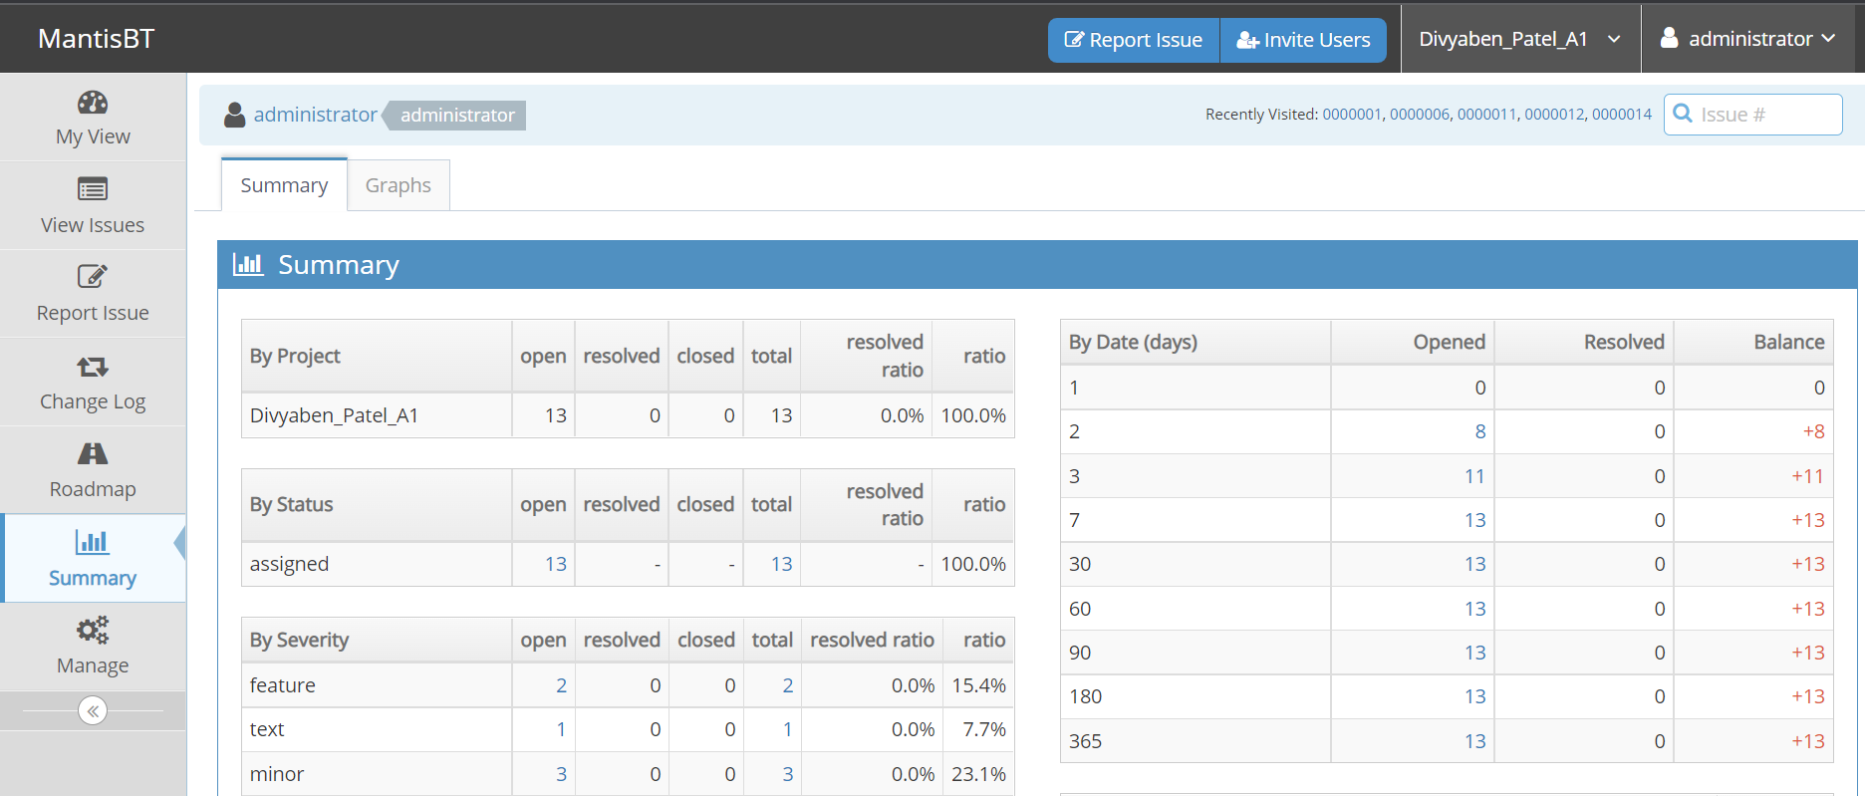

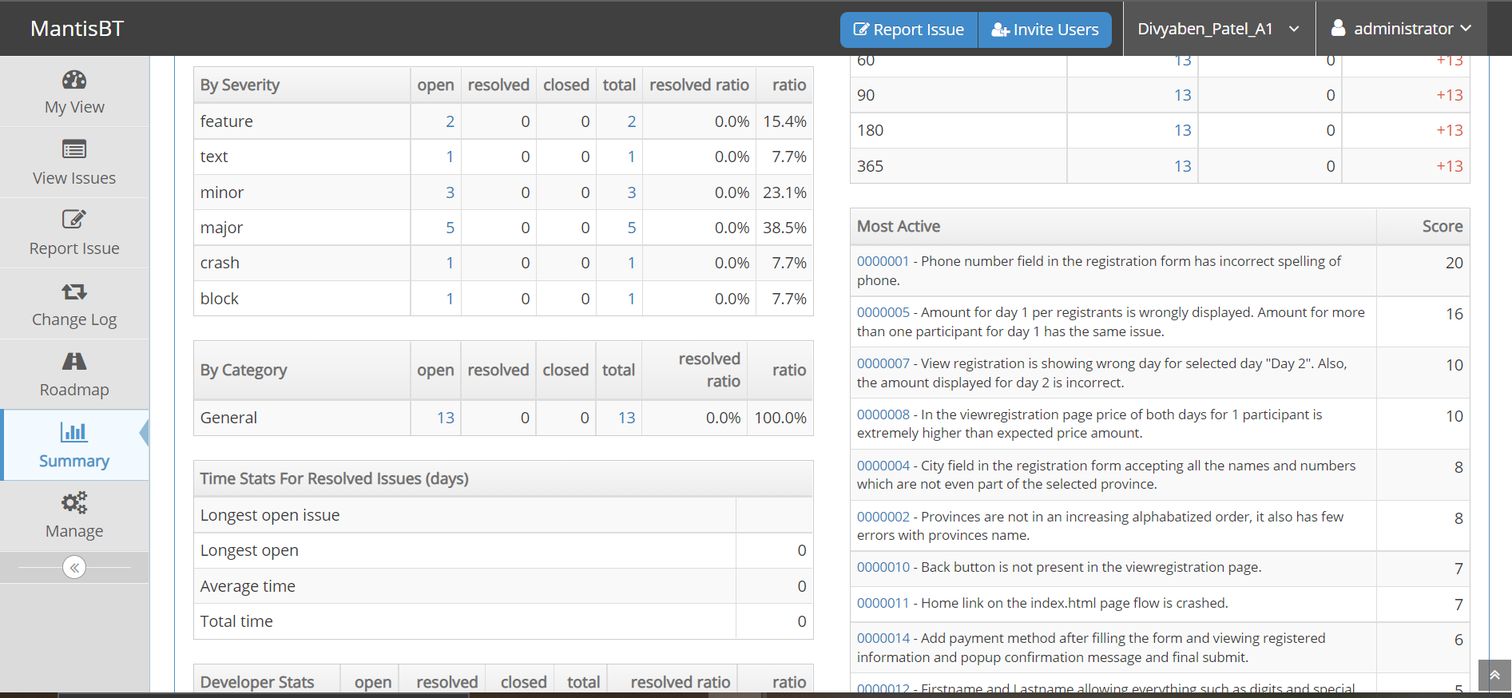

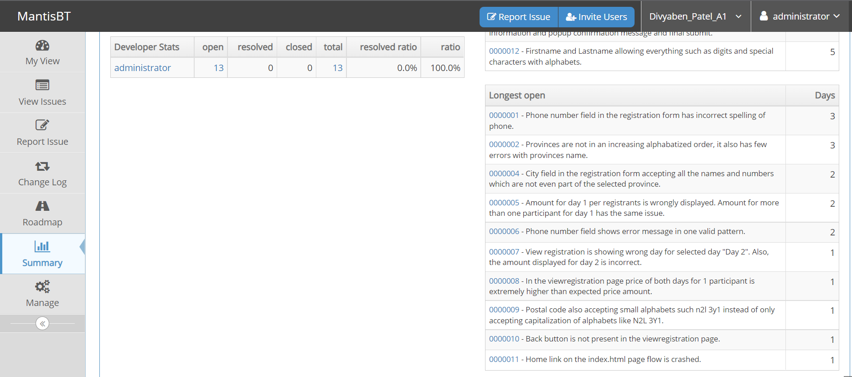

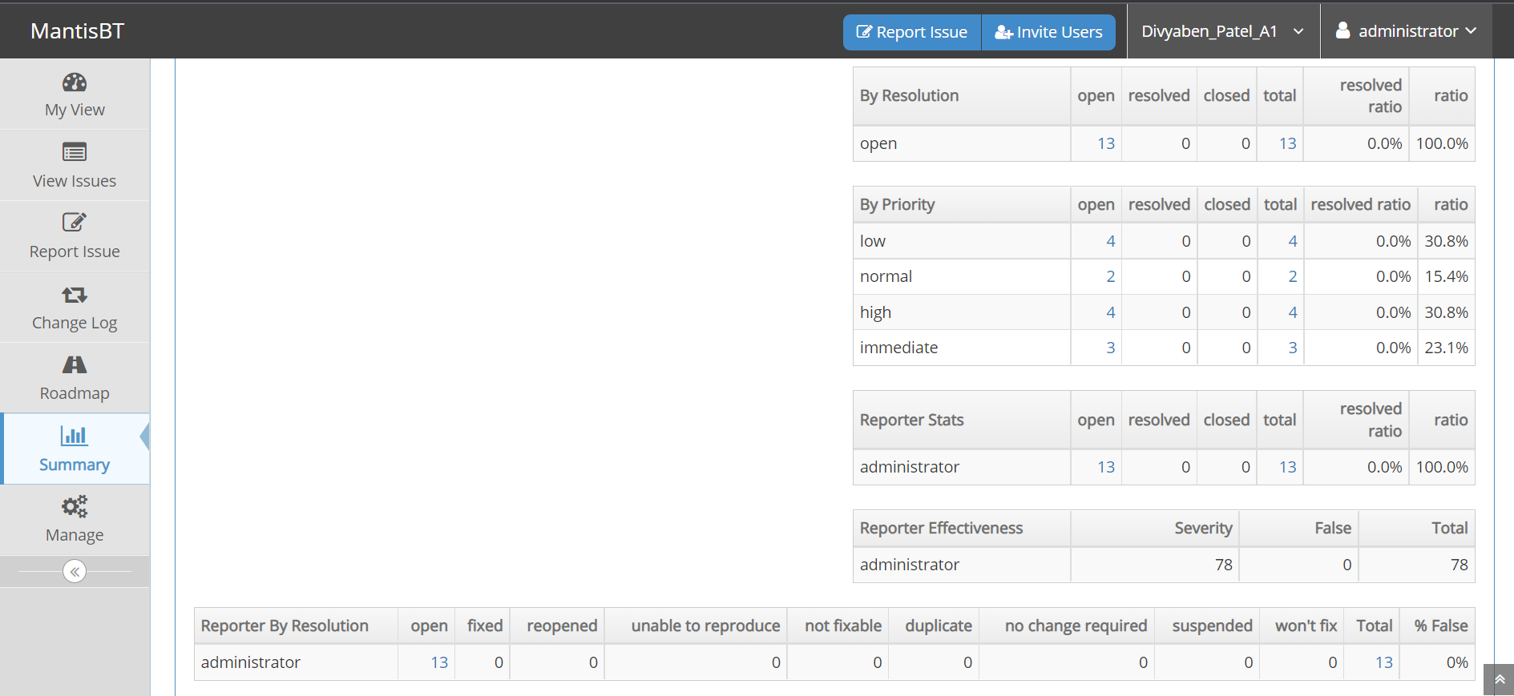

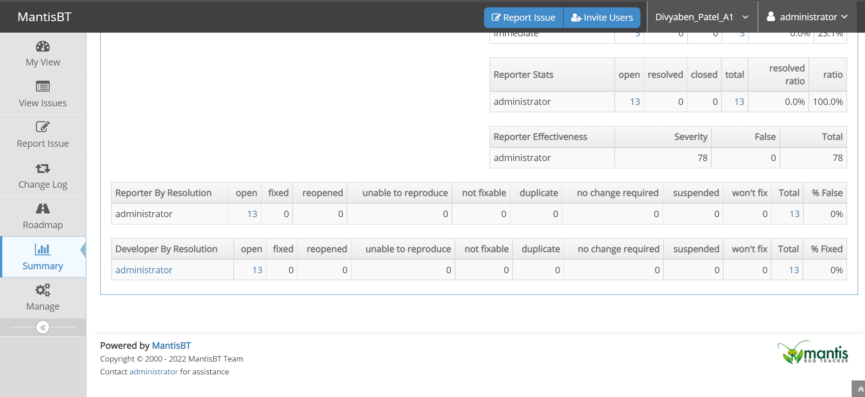

2.2 The image of summary – by severity is as below. This image representation by severity is through the graphs in MantisBT.

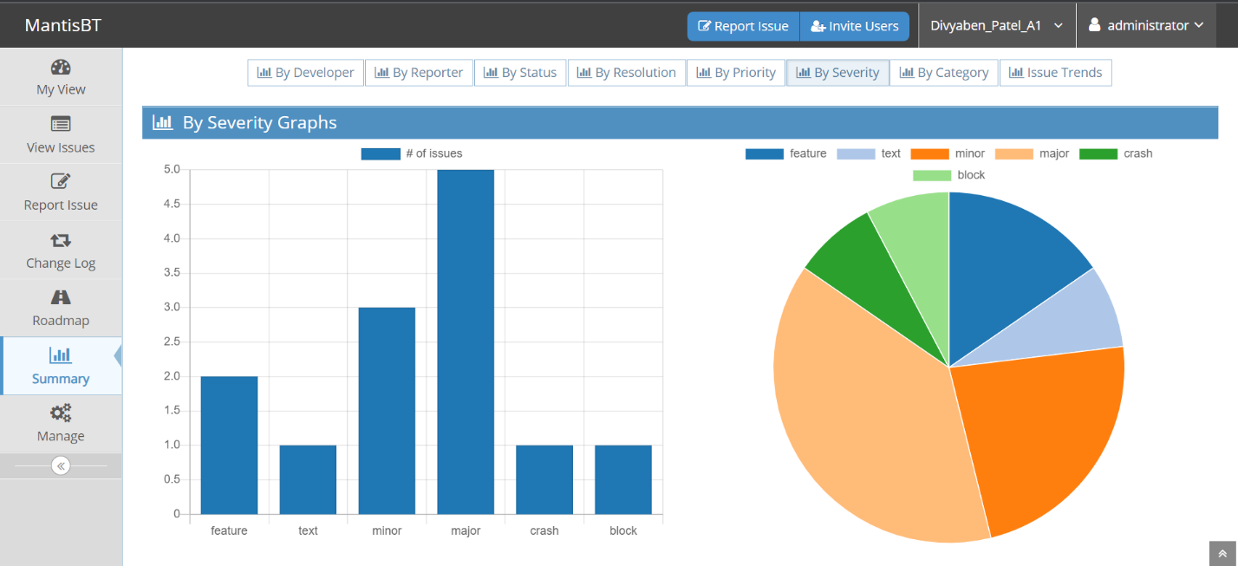

1. Analysis of all the defects and recommendation.

I have discovered more than ten defects and suggested few enhancements features as well. As per my analysis, the web application to register for the event called “THE Event” is not ready to release. This is because, registration form has five major bugs by severity and from which three defects should have to be solved immediately as it is affecting price of the event. Apart from this, another four errors are on high priority. For an instance, “province” field is missing one state name and has spelling mistakes in few. Also, while registrant select “Day 2” in field called “what day are you registering for?”, is showing “Day 3” in view registered details page which is not even part of the selection. For these reasons, this inadequate web application needs quick solution to meet its requirements to make it useful for their end users.

Furthermore, to make this web application more realistic I would suggest one major improvement along with view registration page. In my opinion, this web application must have a payment method after completing registration form and reviewing all the filled details. So, registrants would know how much they are paying for what day of the event. Moreover, payment method page should have back button, popup to confirm the payment as well as final submit button. In addition to this, every mandatory field in the registration form should have a star sign in color red (e.g., *) besides the name of the field.

To see given recommendations, please refer images from subtitle (1.12) for payment method and (1.13) for star sign.

1. Image Reference.
2. https://www.google.com/url?sa=i&url=https%3A%2F%2Fsupport.unity.com%2Fhc%2Fen-us%2Farticles%2F360018915351-How-do-I-add-modify-remove-my-credit-card-information-&psig=AOvVaw3DwtKOHIISORnylPOG-yuh&ust=1643304696424000&source=images&cd=vfe&ved=0CAsQjRxqFwoTCNC4lZj5z_UCFQAAAAAdAAAAABAJ